Ambulance Service Delivery and Efficiency in California

Daniel R. Smiley
Acting Director
State of California, Emergency Medical Services Authority

Steven D. Smiley
1LT, Military Intelligence, 2-5, 1CD
United States Army

Abstract

Cities and counties in the State of California (USA) have the responsibility for ensuring that their citizens have sufficient public safety services available when 9-1-1 is activated. Whereas law enforcement and fire services are generally operated by the public sector, critical ambulance services are often operated by private industry. There are approximately 3600 ambulances distributed throughout California to provide timely emergency medical care. Ambulance services in California are a mixture of public sector services through the fire department or private ambulance services by companies. Service delivery can be separated into three service delivery components: Arranging, financing, and delivery.
In California, local EMS agencies (31 county-based) maintain a statutory responsibility for arranging ambulance service. Financing is through a combination of insurance reimbursement primarily and also public subsidy in some areas. Finally, ambulance services are delivered either by a public service or private entity throughout 337 ambulance zones. These services can be procured by a continuation of existing service (38%) or through a periodic competitive bidding process (23%). In some zones, it is non-exclusive (39%) and the retail market competition is allowed to occur.
The level of service and its effectiveness is substantially equivalent in both private sector and public sector ambulance delivery. This is measured by the use of licensed paramedics. Additionally, response times are substantially equivalent, as measured as a fractile, at 10 minutes or less 90% of the time.
From the perspective of efficiency, when ambulance services are procured through competitive process held at periodic intervals (<10 years), defined service delivery seems to have improved at a lower cost. Unit/hour utilization in private high performing systems can be found at .34 whereas in some system systems it may be as low as .14. A review of 30 ambulance zones, that have a population of 200,000 or greater, shows that there is a trend towards greater efficiency, as measured by unit-hour utilization (number of patient transports/hour), in ambulance services that are competitively procured. Additionally, the unit/hour utilization also appears to improve as the total transports increase due to system size.
When governmental entities are examining the procurement and delivery of critical ambulance services, improved efficiency of ambulance services procured competitively, and in a response area, may be considered when the governing body is reviewing various policy options.

Introduction
In California, cities and counties have the responsibility for ensuring that their citizens have sufficient public safety services available when the emergency telephone system 9-1-1 is activated. Historically, law enforcement and fire services have been generally operated by the public sector. In the case of ambulances, both private industry and fire departments have provided this service. There are approximately 3600 ambulances distributed throughout California to provide timely emergency medical care. Ground ambulance services in California are a mixture of public sector services through the fire department or private ambulance services by companies. Of those ambulances, approximately 74% are private sector services (California Emergency Medical Services Authority 2008). These private sector resources are either provided under contract with a County to provide emergency services or are left to the retail market to provide transport services.
This paper explores the several issues surrounding "privatization" of what is often considered a public sector service is explored within the context of service delivery, efficiency, and competition. Emergency medical services (EMS) systems that include ambulance service delivery as a component often utilize competitive procurement methodologies to ensure that the most efficient service is selected. Using the existing statutory model in California, the relationship between the private and public sector production of ambulance services under conditions of competition was examined compared to a historical non-competitive designation of exclusive operating areas.
With respect to efficiency, the case hypothesis that was examined concerned the issue of ambulance efficiency. If efficiency is the primary variable for competitive selection, then private providers should have an advantage in a competitive procurement of exclusive operating areas. The private production of ambulance services is more efficient, using unit-hour utilization as the measurement, than the public production of ambulance services under varying levels of competition (exclusive and non-exclusive operating areas) in urban based areas where the population is greater than 200,000 in California.
A simple typology for classifying ambulance service delivery systems was used based upon existing statutes. Private ambulance production data was reviewed to determine if it is more efficient than public sector production. Additionally, an evaluation of the data was undertaken to determine if the procurement of ambulance services through a competitive process yielded a more efficient system than through non-competitive means.
Arranging and Choosing Ambulance Resources
When providing services, government must consider the efficiency of the service mechanism, its ability to meet the desired performance level and its ability to conform to other societal goals. In California, there is a preference for using private means of production whenever it can meet these qualifications.
Decreasing government resources and fiscal limits have caused policy makers to consider all of our services to determine whether there are alternative methods for providing them. Among these alternatives is privatization of the service and promotion of a partnership between the public and private sectors. In privatizing a service, the local governments in California have considered whether the service can be provided as a private and whether a sufficient demand exists to entice the private sector to take over the service completely. If the service is either a public good, or if a public subsidy is required, them the government can privatize it through contracts or by encouraging a structured marketplace.
In many cases, it is possible to meet public needs using private resources. These partnerships include contracting and regulatory programs, but also include a role for government as a facilitator and coordinator rather than as a provider of service. Three independent components in the provision of government services have been identified by Kirlin, Ries, and Sonnenblum. These are (1) planning or arranging, (2) financing, and (3) production. They also identified four combination of these functions to describe government involvement in providing services (Sonnenblum, Kirlin and Ries 1977). They also found increased fiscal pressures, the inability to reduce costs, and recognition of other available delivery structures drive local governments to contract with outside providers. When all three functions are performed by the government, it is called a "consolidated arrangement.” Under a "contract," the government plans and finances the service that is then produced by someone else. Under a "regulated" activity, the government's involvement is limited to the planning function. Finally, governments may receive "grants" from higher levels of government and produce the service that is planned and financed by the granting agency.
In California, 31 county-based local EMS agencies maintain a statutory responsibility for arranging ambulance service (California Health and Safety Code 1983). Financing of ambulance services is primarily through insurance reimbursement from MediCare, Medicaid, third-party insurers, and private pay (United States Government Accountability Office 2007). In some cases, ambulance providers also receive public subsidy. Finally, ambulance services are delivered either by a public service or private entity throughout 337 ambulance zones for ground transport services (California Emergency Medical Services Authority 2011). These services can be procured by a non-competitive continuation of existing service (38%) or through a periodic competitive bidding process (23%). In some zones, it is non-exclusive (39%) and the retail market competition is allowed to occur. Of the ambulance zones in California, only 30 ambulance zones have a population base of 200,000 people or greater.

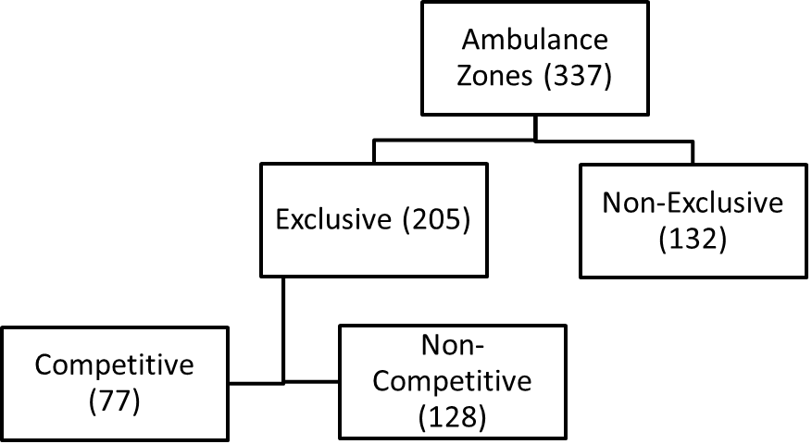
Figure 1 Ambulance Service Zones in California

Various studies of public and private delivery of service do not conclusively show that one is necessarily more efficient or effective. In addition to the performance of the service providers themselves, there are questions of economies of scale, opportunity cost, and use of incentives. Savas and Goodsell both presented studies of the comparative efficiency of the private and public sectors and posited different conclusions. Perhaps a more appropriate conclusion is that neither sector is necessarily more efficient than the other.
When considering whether an alternative to traditional delivery should be undertaken, each case should be considered individually. The development or maintenance of quality public services requires the governmental agency to clearly identify their desired level of outcome and be able to measure them accurately. It also requires the identification of value-based equity and equality goals and the costs that are associated with these policy objectives. In a study of publicly owned fire departments and a private contract fire department, fire protection costs per capita were lower with private contract fire services (Ahlbrandt 1973). Thus, in this sector, private fire protection firms appear to be much more efficient than public firms.
Specifically, the provision of ambulance services has not been subjected to review. The determination of policy makers to provide these services directly, perhaps through the fire department or a third service, or to contract with a private provider of services continues to be a question in California.
In the model of "economic man" as rational and as a profit-maximizer, the profit incentives present in the private sector can be seen as promoting efficient operation. McDavid identified the use of profit-sharing as an incentive for worker productivity that is available only to the private sector (McDavid 1985). Profit based incentives are not intended in the public sector, and alternate incentives with negative connotations, such as "budget-maximizing" and "bureaucratic aggrandizement" have been identified.
When marketplace incentives in order to promote increased efficiency is used, some degree of marketplace competition must be present or created. Privatization of services that result in an unregulated monopoly may result in monopolistic behavior, including limiting production and increasing charges. This would result in a lower level of service at a higher cost than when the service was provided by government under political controls.
Because the private sector is more likely to take on those services that it can run at a profit and leave others for government, shedding of services by government must be examined carefully. Shifting to the private sector of a profitable service that is helping to cover the fixed costs of less profitable services will increase the costs of those services and could increase the total cost of both.
There are assumptions regarding the strength of a marketplace free of external controls as opposed to one with various degrees of regulation. There are assumptions regarding the comparative efficiencies of organizations that are subject to marketplace incentives and those that are not. While these may be subject to empirical tests, they are also, perhaps predominantly, questions whose answers are based on values.
Our society demands various services from our governments that are not available in a free marketplace. Often, the decision about which services are to be offered will be decided in the political arena. For the most part, we expect that these government services are provided in the most efficient manner possible.
In California, the local EMS agencies who select ambulance providers commonly recognize several advantages to competitive bidding as it relates to cost and efficiency. First, limiting marketplace competition and replacing it with periodic, bidding through a government agency to develop an exclusive operating area enhances efficiency by reducing total costs. And, second, resource allocation (using flexible staffing patterns) is easier with private ambulance services than with public sector services.
Ambulance Service Measurement
The efficiency of services can be measured by the amount of inputs required to produce a desired level of output, or by the amount of output produced by a fixed amount of inputs. For government services, the measurement used to judge efficiency is generally the cost. This may be measured as either total cost, or per unit of service, required to provide a desired service level.
Performance measures can be based on structure (e.g., the number of fire stations), process (e.g., the number of responses), or output (e.g., fire losses). When comparing different service delivery systems, it is necessary to use comparable measurements and to identify differences that are based on variables such as seasonal demand patterns. Some EMS managers use Queuing Theory for ambulance deployment and how to best serve their customers. The mathematical study of waiting lines and the consequences of those lines has provided important lesson in the development of flexible deployment and system status management. When Queuing Theory is applied to EMS, it is used to examine the three primary processes: Number of expected calls, number of available ambulances, and time to deliver the service. This application is often called flexible deployment or system status management (Stout 1983).
First, EMS managers determine the historical demand patterns, by time of day and day of week. Second, with this data in mind, the number of ambulances are determined to achieve a specified response time (ie 10 minutes or less, 90% of the time). Additionally, the locations of those ambulances are determined to decrease their response times to calls based upon those historical demand patterns. Finally, the service time in a given area must be calculated. In most urban systems, the total time to complete one transport is approximately one hour. This includes response to call, time at scene to treat a patient, and transport time to the hospital. Additional time components include time at the hospital and any time required to prepare the ambulance for the next call. In rural areas, or on long distance transports, the service time may be greater than 1 hour. Based upon the local requirements, considerations during the calculation process must include any time delay between when a call is received and when it is dispatched. This would be especially true if the dispatcher must hold the call in a queue until an ambulance becomes available.
Several measurements for ambulance service efficiency have been used in various settings. The most common measurement for productivity is Unit-Hour Utilization (Transport). This measurement is focused upon the discrete unit of transport of a patient to a hospital. This measurement lends itself well to integration with fiscal analysis as only transport is a reimbursable feature under insurance.
Some public systems also use Unit-Hour Utilization (Call Response). This only shows how many calls are responded to within a given time period and does not take into consideration transport.
In order to evaluate the cost of a system, the measurement of Unit Hour Cost is often used. Unfortunately, this measurement is not readily available in most cases, measured in many different ways, and difficult to obtain consistent measurement in public sector fire departments due to the mix of fire suppression activities compared to EMS. In some systems, the availability of data related to cost per capita or Cost per transport may be obtained also (United States Government Accountability Office 2007).
In California, EMS managers that lead high performance ambulance services typically employ unit hour utilization (UHU) as a measure to gauge productivity and relative efficiency. Sophisticated software programs can now take computer-aided dispatching data and calculate the average number of calls in the day and thus, the UHU for an EMS system.
A review of the data can determine where delays occur in the system by crew, hospital, geographic location, etc. Some EMS systems measure UHU differently. Agencies may measure only calls that include patient transport, while other systems also include cancelled calls, patient refusals or standbys.
Unit-Hour Utilization as a Measure of Efficiency
The level of service and its effectiveness is substantially equivalent in both private sector and public sector ambulance delivery. The two primary factors for measuring effectiveness are the type of service delivered and the response time. The type of ambulance service that is delivered for emergency calls in California is called advanced life support services by the use of licensed paramedics. Additionally, response times are substantially equivalent, as measured either as a fractile, at 10 minutes or less 90% of the time, or as an average of 5 minutes.
For the purposes of this review, a unit hour is equal to one hour of service by a fully equipped and staffed ambulance available for dispatch or assigned to a call. Ambulance services with average turnaround times greater than one hour, can make adjustments to the listed formulas to achieve more accurate estimates.
Utilization is a measure of productivity, which compares the available resources (i.e. unit hours) with the actual amount of time those units are being utilized for patient treatment and transport or other productive activity. This measurement is calculated to determine the percentage of unit hours actually consumed in productivity compared with the total staffed unit-hours.
The calculation of Unit-Hour Utilization (UHU-T) is commonly determined by taking the average number of ambulance transports per week and dividing by the average number of ambulance unit hours produced in a week.
UHU-T = (Ambulance Transports per Week) / (Ambulance Unit Hours Produced)
Typically, EMS organizations strive for the highest utilization rates possible. The ambulance industry has utilized the following general scale when evaluating overall unit hour utilization:

Unit Hour Utilization Range
.55 - .45 – High Utilization
.45 - .35 – Above Average Utilization
.35 - .25 – Average Utilization
.25 - .15 – Below Average Utilization
.15 - .01 – Low Utilization

Unfortunately, direct comparison of unit hour utilization between separate ambulance organizations may have limitations as utilization rates are often dependent on a diverse number of other mitigating factors such as the presence of response time standards, shift length, overall time or length of transports; impact on employee wellness and safety, transport times and turnaround times as well as a variety of other operational and administrative issues.
The California Ambulance Review
Methodology

In this review and comparison of UHU productivity, all 30 Ambulance zones with population response areas of greater than 200,000 were selected. Of these, 22 were private and 8 public. Of the 22 private entities, 12 were competitively selected and 10 were selected without a competitive process.
Data for this review was collected from multiple public sources. The California Emergency Medical Services Information System (CEMSIS), local EMS plans, and reported information from providers to the California Emergency Medical Services Authority (EMSA). The two data elements collected for this analysis included the average weekly number of unit-hours produced by the ambulance provider and the total yearly number of ambulance transports.
This data was compiled and analyzed using Minitab statistical software. One-way Analysis of Variance (ANOVA) was selected as the test of significance to compare means. The assumption is that the populations are normally distributed.

Results
The data for the 30 ambulance zones include responses to 9-1-1 emergency calls in all cases. Depending upon the ambulance zone response configuration, the response to non-emergency calls may also be included in the results.

Zone Area | Type | EOA Method | Total Transports | U/H Util Transport
Los Angeles | Public | Excl Non-Comp | 146977 | 0.306
Los Angeles Co | Private | Excl Competitive | 114000 | 0.313
San Bernardino Co | Private | Excl Non-Comp | 112000 | 0.299
Fresno Co | Private | Excl Competitive | 89197 | 0.343
Alameda Co | Private | Excl Competitive | 87242 | 0.344
Santa Clara Co | Private | Excl Competitive | 69061 | 0.331
Kern Co | Private | Non-Exclusive | 68000 | 0.284
San Diego | Public | Excl Competitive | 63000 | 0.249
Contra Costa Co | Private | Excl Competitive | 54919 | 0.277
Riverside Co | Private | Excl Non-Comp | 50000 | 0.247
San Diego | Private | Excl Non-Comp | 50000 | 0.267
San Francisco | Public | Non-Exclusive | 40880 | 0.234
San Joaquin Co | Private | Excl Competitive | 39512 | 0.212
Stanislaus Co | Private | Excl Non-Comp | 38000 | 0.205
Sacramento | Public | Non-Exclusive | 34606 | 0.305
Santa Barbara | Private | Excl Non-Comp | 34000 | 0.204
Long Beach | Public | Excl Non-Comp | 32000 | 0.262
Solano Co | Private | Excl Competitive | 25440 | 0.275
Anaheim | Private | Excl Competitive | 25000 | 0.270
Ventura Co | Private | Excl Non-Comp | 25000 | 0.219
San Mateo Co | Private | Excl Competitive | 24416 | 0.328
Placer Co | Private | Excl Non-Comp | 22000 | 0.184
Sacramento Co | Public | Non-Exclusive | 20175 | 0.178
Irvine | Private | Excl Competitive | 20000 | 0.202
San Luis Obispo | Private | Excl Non-Comp | 18684 | 0.214
Monterey Co | Private | Excl Competitive | 17486 | 0.144
Sonoma Co | Private | Excl Competitive | 16382 | 0.198
Santa Cruz Co | Private | Excl Non-Comp | 12356 | 0.253
Huntington Beach | Public | Excl Non-Comp | 10000 | 0.286
Santa Ana | Public | Excl Non-Comp | 9000 | 0.172

Discussion
When comparing the unit-hour utilization means of both private (n=22) and public (n=8) providers, private providers had a mean unit-hour utilization (transport) of .255 with a standard deviation of .056, whereas public providers had a mean of .249 with a standard deviation of .052. This is not a significant difference. However, the variance was more pronounced in public providers.
One-way ANOVA: U/H Util Transport versus Type (Private vs. Public)

Source DF SS MS F P
Type 1 0.00024 0.00024 0.08 0.784
Error 28 0.08694 0.00311
Total 29 0.08718

S = 0.05572 R-Sq = 0.27% R-Sq(adj) = 0.00%

Individual 95% CIs For Mean Based on
Pooled StDev
Level N Mean StDev -------+---------+---------+---------+--
Private 22 0.25518 0.05681 (---------*---------)
Public 8 0.24880 0.05234 (----------------*---------------)
-------+---------+---------+---------+--
0.225 0.250 0.275 0.300

Pooled StDev = 0.05572

When comparing the unit-hour utilization between the selection methodology of both private and public, between those that are competitively selected (n=13) or are selected non-competitively (n=17), the ambulance services selected through a competitive process have a mean of .268 and those selected non-competitively have a mean of .242. At a 95% confidence interval, it appears that the competitively selected provider will have a mean unit-hour utilization at an efficiency level that is better than the best non-competitively selected provider.

One-way ANOVA: U/H Util Transport versus EOA Method Adj.

Source DF SS MS F P
EOA Method Adj. 1 0.00502 0.00502 1.71 0.202
Error 28 0.08216 0.00293
Total 29 0.08718

S = 0.05417 R-Sq = 5.75% R-Sq(adj) = 2.39%

Individual 95% CIs For Mean Based on
Pooled StDev
Level N Mean StDev ----+---------+---------+---------+-----
Competitive 13 0.26827 0.06411 (-----------*------------)
Non-Compet. 17 0.24218 0.04531 (----------*----------)
----+---------+---------+---------+-----
0.225 0.250 0.275 0.300

Pooled StDev = 0.05417

As total transports increase, the unit-hour utilization tends to increase also. This may be related to the nature of rural and urban ambulance services. The P value when analyzing this is .216. Although not statistically significant, graphically it begins to show some correlation.

Figure 2 Total Transports compared to Unit-Hour Utilization
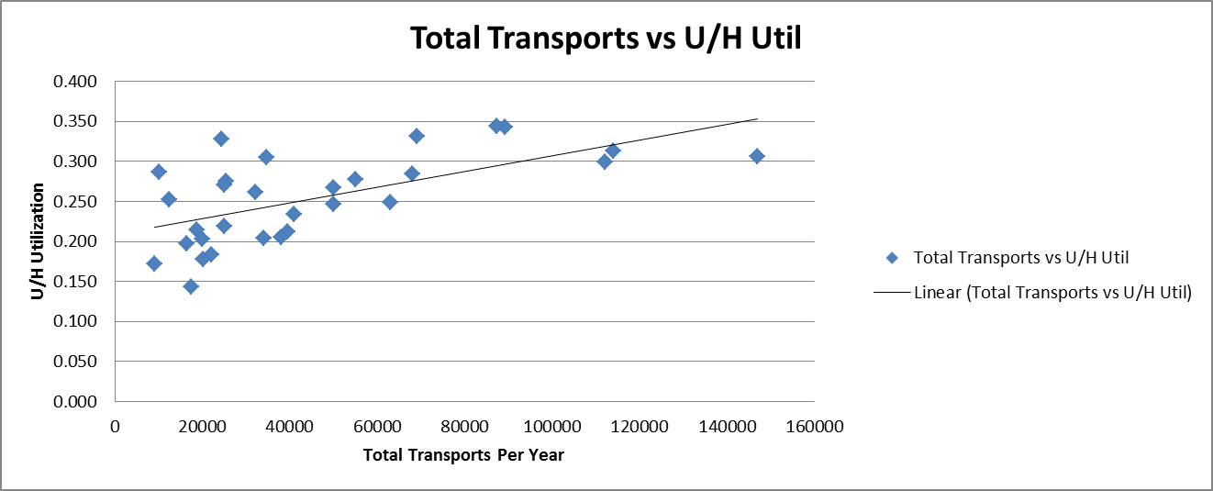

Although there is no significant difference between private and public in terms of unit-hour utilization, when trending the distinction between public and private by total transports, it appears that a potential exists for greater unit-hour utilization by private ambulance services. This could be a factor of the use of surplus ambulances for non-emergency transportation.

Figure 3 Private and Public Unit-Hour Utilization compared to Total Transports
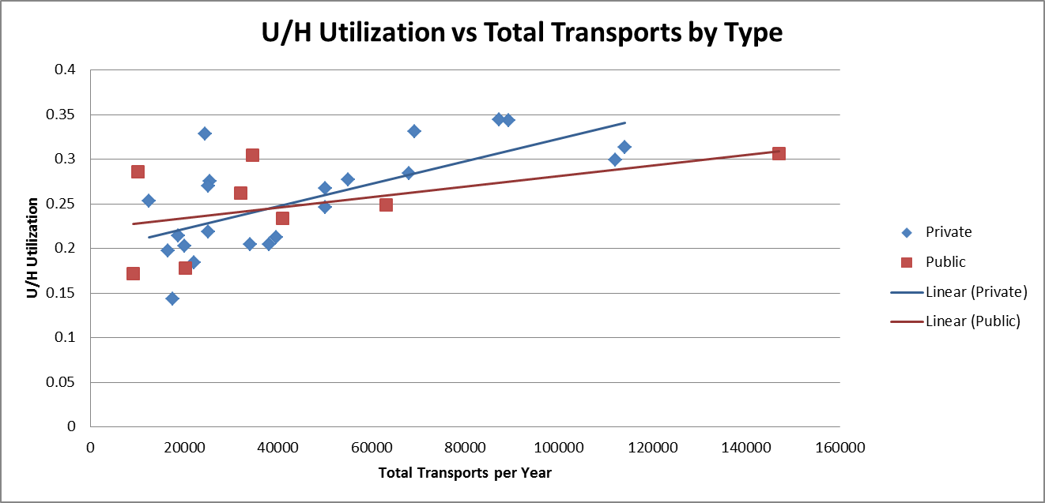

Conclusion
When governmental entities are examining the procurement and delivery of critical ambulance services, the efficiency of ambulance services, and potential for subsequent reduced cost, may be considered when the governing body is reviewing various policy options. When arranging for an ambulance zone for competitive procurement, governmental entities should examine the potential for improved efficiencies that may be found in areas that have higher populations and a higher number of transports.
From the perspective of efficiency, our review shows that there is a trend to greater efficiency, as measured by unit-hour utilization (number of patient transports/hour) in ambulance services that are competitively procured.
More research in this area would be beneficial in identifying factors that will lead to more informed choices about the selection of ambulance services.

References
Ahlbrandt, Roger S. Municipal Fire Protection Services. Beverly Hills: SAGE Publications, 1973.
California Emergency Medical Services Authority. Ambulance Resources in California for Surge Response. Government Report, Sacramento: California EMS Authority, 2008.
California Emergency Medical Services Authority. Ambulance Zones, Ground; Exclusive Operating Areas Status. Government Report, Sacramento: California Emergency Medical Services Authority, 2011.
California Health and Safety Code. "Section 1797.85." Sacramento, 1983.
McDavid, James C. "The Canadian Experience with Privatizing Residential Solid Waste Collection Services." Public Administration Review, 1985: 602-608.
Sonnenblum, Sidney, John J. Kirlin, and John C. Ries. How Cities Provide Services. 1977.
United States Government Accountability Office. Ambulance Providers: Costs and Expected Medicare Margins Vary Greatly. Government Report, Washington D.C.: GAO, 2007.

