Life Transitions from Military to Civilians: Modeling Public Policy Implications

Alexander V. Libin, PhD^{1,2}; Manon M. Schladen, EdS², Julie C. Chapman, PhD^{4,1}, Banks Nathaniel, BS⁴, Miriam I. Philmon, BS², Sunil Sen-Gupta, PhD³.

1. Georgetown University; 2. MedStar Health Research Institute; 3. George Washington University; 4. DC VAMC, Washington, DC, USA
Abstract. The process of transitioning from post-deployment to civilian or non-active duty services is complex, multi-factorial, and, at the same time, highly individual. Nearly 1.5 million United States (U.S.) Veterans are returning from Iraq and Afghanistan, and while most of the Veterans experience problems related to post-deployment adaptation, some groups become especially vulnerable to post-military life challenges. Public policy research in this area aims to explore a critical phase during life transitions, focusing on a special vulnerable population: U.S. homeless Veterans. Our working definition of homelessness builds on accepted U.S. Department of Veterans Affairs health codes that identify a Veteran as homeless based on the lack of housing at a single or numerous time points, and recent reports on homelessness in Veterans, including the recent Opening Doors: Federal Strategic Plan to Prevent and End Homelessness initiative. These reports emphasize that a period of particular concern for Veterans, especially those with physical impairments and mental health problems, is the critical transition period from post-deployment programs (e.g. the Yellow Ribbon Reintegration Program, RYRP, and similar psychosocial adaptation programs) to full and active community participation and gainful employment. It is during this critical transition period that homeless episodes are most likely to occur.
Existing services integrate government and private sector activities addressing homelessness in Veterans using a variety of methods. Epidemiological studies develop a profile of homeless Veterans to identifying post-deployment periods most sensitive to homeless episodes. The development of clinical tools for psychological health screening enables the creation of rehabilitation interventions specific to Veterans who are experiencing homelessness. The Life Transitions conceptual framework builds on a modified Public Health and Policy Model for Vulnerable Populations to guide the analytical design of study variables and frame instrument development procedures. Training activities employ findings from various service models for assisting homeless Veterans thus merging research-driven and service-based evidence into a unified framework to guide homeless Veteran research.

Introduction

The process of transitioning from post-deployment to civilian or non-active duty services is complex, multifactorial, and, at the same time, both highly social and individual. The research aim of the COMPASS^{home} framework, a proposed Collaborative Network for Community Integration for Homeless Veterans residing in the Metropolitan Washington, DC (USA) area, is to build a public management capacity incorporating both governmental and non-governmental agencies focused on developing a framework of policies to address a critical phase during military-to-civilian (MtC) life transition and on a special vulnerable population: homeless Veterans. Our working definition of homelessness builds on accepted U.S. Department of Veterans Affairs (VA) health codes that identify a Veteran as homeless based on the lack of housing at a single or numerous time points, and recent reports on Homelessness in Veterans, including the recent Opening Doors: Federal Strategic Plan to Prevent and End Homelessness initiative. These reports emphasize that a period of particular concern for Veterans, especially those with cognitive impairment due to traumatic brain injury (TBI) and mental health problems such as post-traumatic stress disorder (PTSD), is the critical transition period from post-deployment programs (e.g. the Yellow Ribbon Reintegration Program, RYRP, and similar psychosocial adaptation programs) to full and active community participation and gainful employment. It is during this critical transition period that homeless episodes are most likely to occur.

COMPASS^{home} Framework: A proposed Collaborative Network for Community
Integration

The main goal of the proposed District of Columbia Collaborative Network for Community Integration in Homeless Veterans (COMPASS^{home}) is to establish new practices and enhance services aimed at homeless Veterans, to promote Veterans’ psychological health and foster their reintegration back into the community. This goal is achieved through interdisciplinary research and training in collaboration with the government-sponsored District of Columbia Veteran Affairs Medical Center (DC VAMC) Homelessness Program, and Veterans Health Administration sponsored research (the MIND Study). The COMPASS^{home} network is thought of as a collaboration between governmental structures in the U.S. such as the Department of Veterans Affairs, the National Institutes of Health, the Uniformed Services University of the Health Sciences, and non-profit and private institutions including top-ranked rehabilitation research centers (National Rehabilitation Hospital and MedStar Health Research Institute,) and academic facilities (Georgetown University and Catholic University of America) (see Figure 1). COMPASS^{home} research and training activities address homelessness in Veterans using a variety of methods: from an epidemiological study to develop a profile of homeless Veterans to identifying post-deployment periods most sensitive to homeless episodes; from the development of clinical tools for psychological health screening to rehabilitation interventions specific to Veterans who are experiencing homelessness. The COMPASS^{home} conceptual framework builds on a modified Behavior Model for Vulnerable Populations to guide the analytical design of study outcomes, including new policies and development procedures. Training activities employ findings from various service models for assisting homeless Veterans thus merging research-driven and service-based evidence into a unified framework to guide homeless Veterans research.
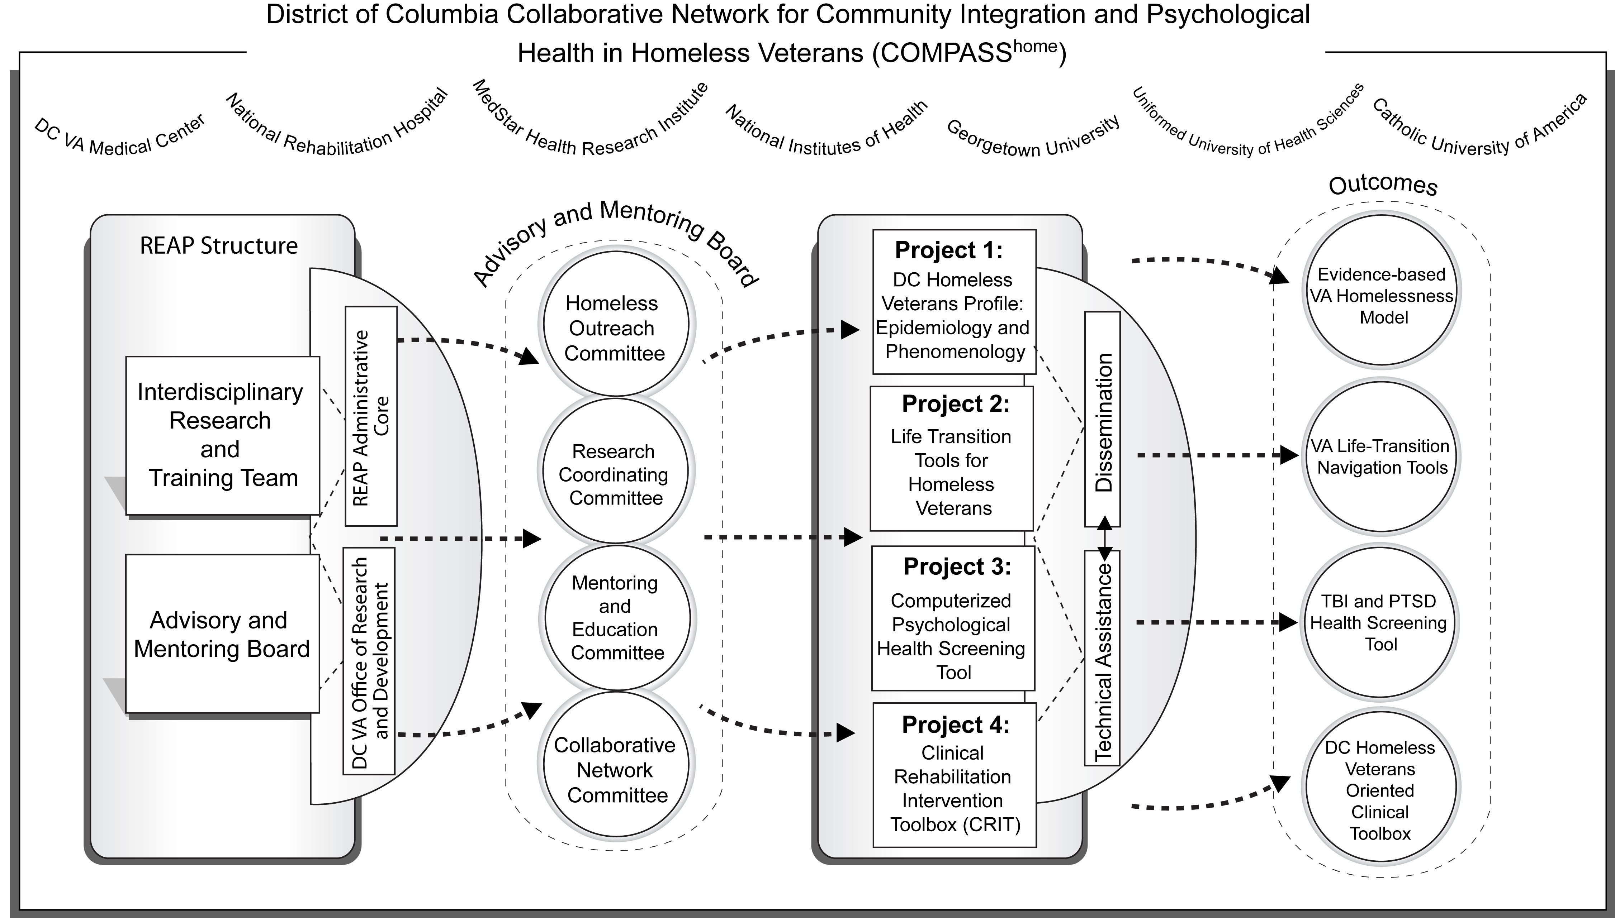
Figure 1. COMPASS^{home} Research and Training Framework
The main interactive mechanism for capacity building is the COMPASS^{home} Advisory and Mentoring Board (AMB) that includes four main cores incorporating governmental and non-governmental agents in its working framework: the Homeless Outreach Committee (DC VAMC and Yale University); the Research Coordinating Committee (ACOS, DC VAMC and NRH), the Mentoring and Education Committee (Georgetown University and DC VAMC), and the Collaborative Network Committee (MedStar Health Research Institute and National Institutes of Health).

Public Policy: Empirical Approach to Community Integration

The challenges of economic and social stress, especially during the ongoing global economic crisis, directly impact public management building capacity. Vulnerable populations, such as homeless military Veterans, are especially at risk during these turbulent times. The unique feature of the COMPASS^{home} capacity building methodology is that a collaboration between governmental and non-profit and private sector is enhanced by engaging stakeholders in problem solving so as to increase the likelihood of achieving public and political support of workable approaches to resolve critical problems.

Income and education per capita rates in the city of Washington, DC are very low compared to the nationwide rates. The DC VAMC is an inner city medical center with a majority low socioeconomic status (SES) and literacy patient population, which present an array of risk factors for homelesness. The DC VAMC is one of four pilot sites in the Disability Evaluation System (DES). (The remaining 3 sites are Walter Reed Army Medical Center, Bethesda National Naval Medical Center, and Malcolm Grow Air Force Hospital at Andrews Air Force Base, Maryland). The DES derived from one of the recommendations of the Dole-Shalala Commission for providing greater continuity of care for military personnel in the transition from DOD to VA. The DES streamlines the multiple examination system that is used to exist upon discharge from the military and application for VA health as well as compensation and benefits programs. Due to its selection as a pilot site, many new Veterans with war-related cognitive and emotional difficulties receive evaluation at the DC VAMC.

During the preparatory phase of developing the District of Columbia (DC) Homelessness Collaborative Network, we identified such pressing needs as: building an epidemiologic profile of the DC VAMC catchment area homeless Veteran population, establishing evidence-based guidelines and field-oriented tools for screening of PTSD and TBI symptoms, and developing real time resource navigation guidelines within a research-to-practice framework.

Therefore, COMPASS^{home} research outcomes would provide special advantages to enhance the services provided to Operation Iraqi Freedom (OIF) and Operation Enduring Freedom (OEF, Afghanistan) Veterans. The primary outcome of the study will be a significant enhancement to existing practices of care for homeless Veterans. The study will result in evidence-based guidelines for OIF/OEF Veterans to help them transition through difficulties of post-deployment adjustment. Study secondary outcomes, such as epidemiologic psychological health profiles and community integration mapping, can be used to refine training, research and collaborative strategies. These refinements facilitate the development of larger nation-wide homelessness research networks and foster replication of best practices of care in homeless, low-income and vulnerable populations.

COMPASS^{home}: Coordination of Activities

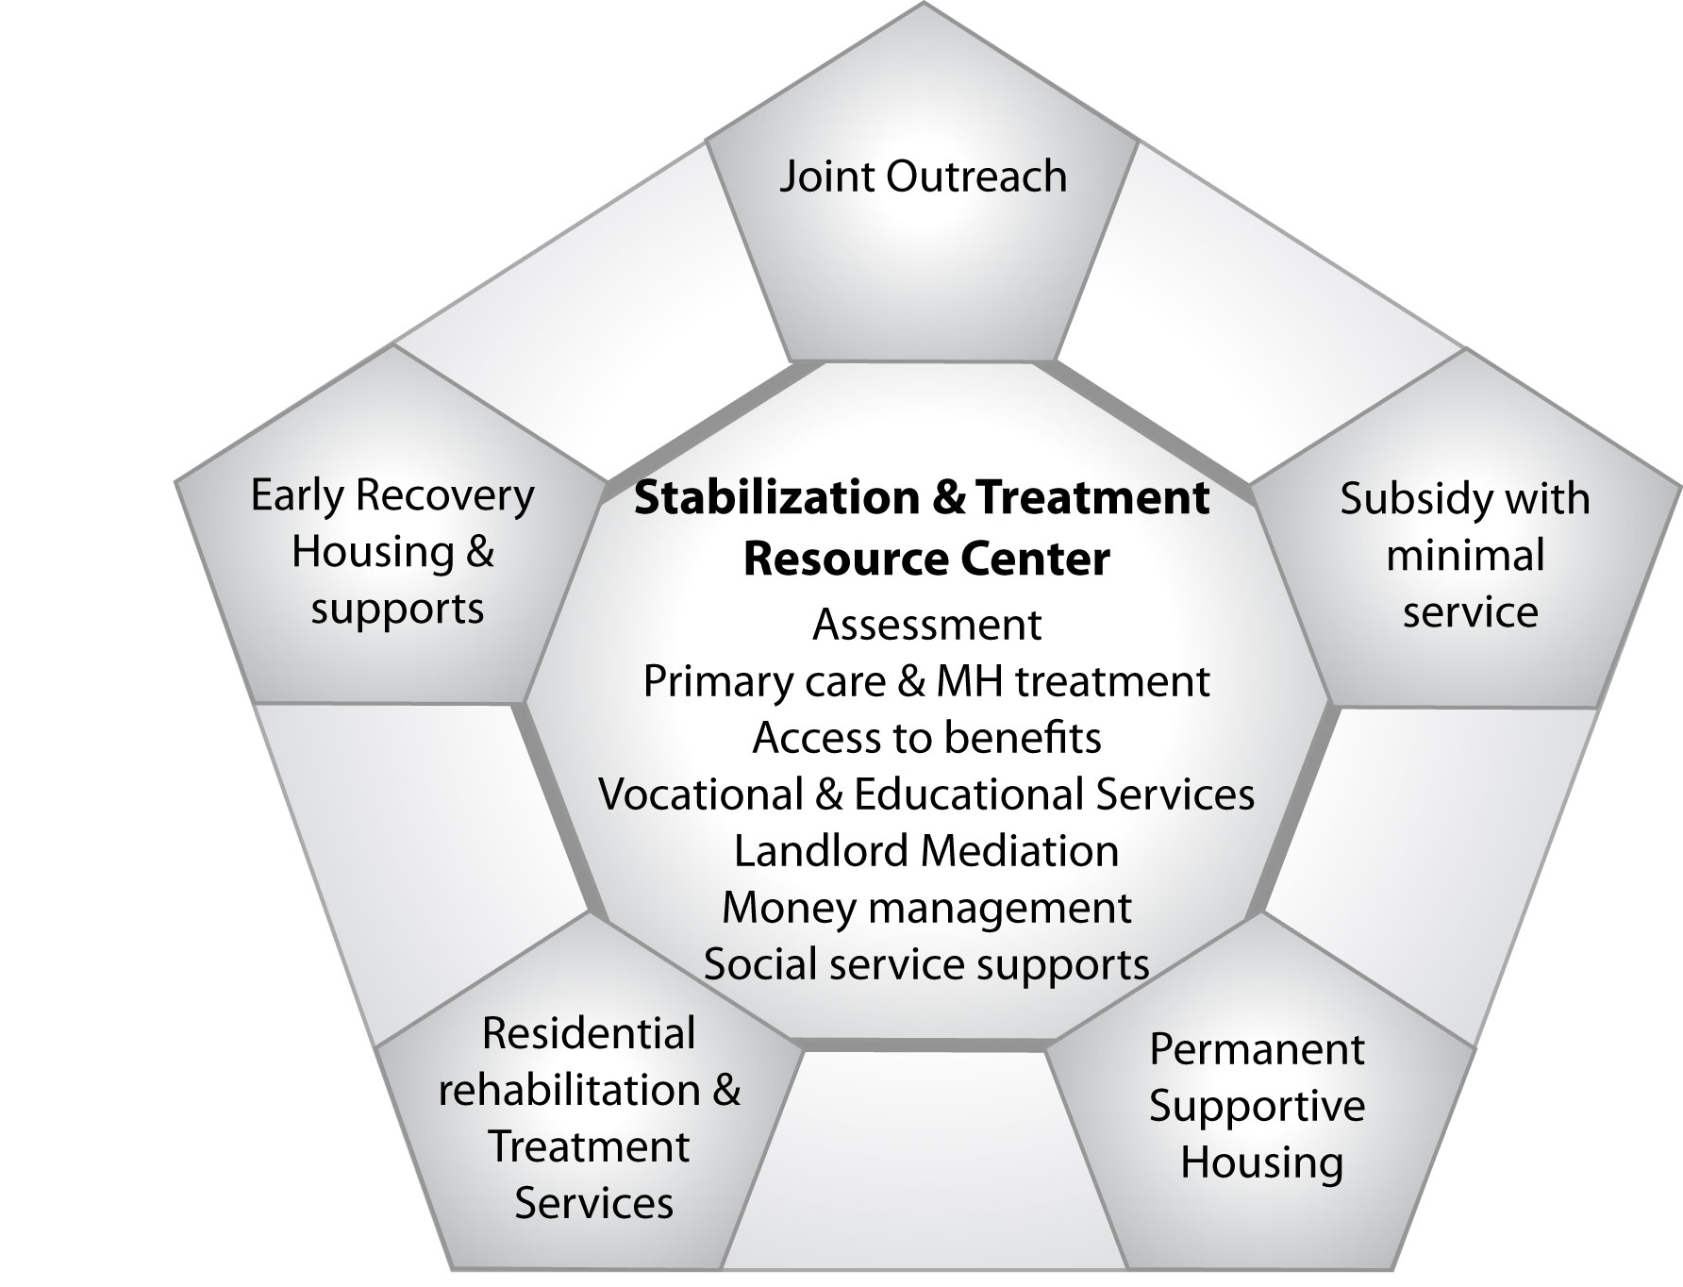
The DC VAMC provides services to Veterans who are homeless and seeking housing assistance. The Health Care for Homeless Veterans (HCHV) program, established since 1990, uses a three-tiered model in its approach: Outreach, Grant and per Diem and HUD/VASH, housing assistance with case management support (See Figure 2). During 2009, HCHV recorded 1,035 encounters with Veterans. Of the Veterans involved in these encounters, 360 met the definition of chronic homelessness. These findings are based on VA mandatory data collection which screens homeless Veterans as a standard needs assessment. Once the needs of homeless Veterans have been assessed, they enter a continuum of care that addresses their primary, mental health and substance use treatment and psychosocial rehabilitation care needs, including housing. The study will engage a population of nearly 1,000 homeless DC Veterans in TBI/PTSD services and training activities, from which new data will be collected.

Figure 2. Coordinating Collaborative Efforts

In order to provide permanent housing to Veterans, the VA and HUD have established the HUD/VASH program which provides vouchers enabling qualified Veterans to lease a permanent housing unit. Since the beginning of the program, the DC VAMC has received a total of 413 HUD/VASH vouchers. Homeless Veterans enjoy the benefit of HUD/VASH subsidized housing, however, the timeline for moving a Veteran from homelessness to permanent housing ranges from 4 to 12 weeks. During this time frame, many Veterans remain homeless, living in shelters, with friends or family or in the worst case, on the street. It is essential that the VA develop additional transitional housing beds for Veterans who are waiting to secure permanent housing. The Washington DC VAMC is in the process of building a 77 bed Homeless Domiciliary on Center grounds. Every year since 1999, The Washington DC VAMC Homeless Program has hosted a CHALENGE meeting and invited Veterans and community parties. The goal of these meetings is to survey the attendees and compile all of the data possible concerning homelessness. The CHALENGE meeting also surveys Veterans in order to solicit information about what Veterans think they need to end homelessness.

As part of this trans-disciplinary network, a strong emphasis will be placed on educating, training and mentoring of new investigators as well as on serving as an educational resource for members of the VA community working to alleviate homelessness in DC Veterans. During years 1 and 2, pre-doctoral trainees will work under the mentorship of senior investigators in pre-defined pilot projects. During years 3-5, proposals for further pilots will be solicited from existing trainees as well as from advanced students at the academic programs of the participating institutions, as additional funding become available. Applications will be evaluated on trainees’ experience with the homeless population and measures and/or interventional methodologies in the pilot research areas of interest.

Network Tools: Modeling Public Policy Decisions Implementation

Several mechanisms are modeled to execute public policy capacity building and collaborative network goals.

Research Modeling Template 1: DC Homeless Veterans Profile: Epidemiology

Research and training activities identified in Template 1 focus on exploring and understanding the complex nature of homelessness and contributing risk factors for homelessness, such as cognitive impairment due to TBI, PTSD diagnosis, and socio-economic and demographic variables, in OIF/OEF Veterans receiving services at the Homeless Clinic at DC VAMC.
Background: To date, information regarding the complete epidemiologic profile, including physical and psychological health status, of low-income/impoverished and homeless Veterans who reside in shelters, on the street, or in inaccessible homes, is limited. Also, generic physical and psychological health status measures have not adequately captured the concept of homelessness and contributing factors among the Veteran population. Further, perception of the homelessness among Veterans is varied. It differs among Veterans themselves, among clinicians who serve them, as well as among social workers and case managers who work with homeless Veterans.Error: Reference source not found Factors that might have linear or non-linear relationships with homelessness in Veterans are very diverse. For instance, of 435 Veterans characterized by incarceration, 12% reported recent homelessness (within the past month), and 55% reported chronic homelessness.
Research Objective: To ensure that homelessness in Veterans can be addressed in a meaningful and effective way resulting in reducing the number of homeless episodes in an identified population, as well as in preventing the risk at homelessness in returning Veterans, we propose to conduct an epidemiological study of homeless Veterans characterized by both recent and chronic homelessness. The study will provide an array of new information that will also be applicable to other vulnerable populations in the DC catchments area and nationwide. Hence, the primary goal of this study is to explore the course of homelessness in OIF/OEF Veterans of both genders, aged 21 to 55, with various socio-economic backgrounds and physical and psychological health statuses. The secondary goal is to build an epidemiologic profile of DC homeless Veterans with identifiable risk factors such as TBI, PTSD, and substance abuse, and related key indicators of health, function and participation including employment.
Research Design and Methods: This is a cross-sectional study with a projected sample of 309 Veterans, selected using the definitions of homelessness and sampling- and case-ascertainment methods. The study employs the Community Integration Model for Vulnerable Populations (see Figure 3) as a theoretical basis.
Figure 3. Community Integration Model in the Context of Care for Vulnerable Populations
The model will be expanded to include factors relevant to examining the rates of homeless episodes and prevalence of associated health outcomes of OIF/OEF Veterans as a vulnerable population. The Personal Characteristics (i.e., Predisposing, Enabling, and Need Factors) are used to explain Veterans’ Personal Health Practice, including the use of service-connected health check-ups, and Health Status. Predisposing Factors are attributes that allow a Veteran to seek care. Enabling Factors are traits that assist or inhibit an individual in seeking care. Need for Care factors are the subjective (Perceived) health status of the Veteran and the objective (Evaluated) health status that may motivate the Veteran to seek health services. The model is described in the Social Structure characteristics of the Predisposing component that include (a) duration of post-deployment period, and literacy; (b) pre-deployment characteristics (e.g., foster care, group home placement, abuse and neglect history); (c) residential history (e.g., number of homelessness episodes); (d) living conditions (e.g., street, shelter, group home, etc.); (e) mobility (moves between communities and dwellings); (f) criminal behavior and prison history; (g) victimization; (h) mental illness and/or mental health problems including PTSD; (I) cognitive impairment due to TBI or mental health problems; and (j) substance abuse. The Enabling component includes personal and family resources, such as receipt of service-connected benefits, competing needs, and availability and use of information sources. Community resources include the availability of social services. The Need component might include perceptions and evaluated need regarding conditions of special relevance to vulnerable populations, such as tuberculosis or sexually transmitted diseases, particularly, acquired immunodeficiency syndrome (AIDS).

The Personal Health Practices domain includes preventive care behavior (e.g., diet, exercise, self-care, and tobacco cessation), adherence to care, and use of DC VA Homeless Clinic health services. The Outcomes domain includes perceived and evaluated health status and satisfaction with care (this domain will be studied in-depth in the associated Research Modeling Template 2).

Analysis and Outcome Modeling: A multiple regression analysis and logistic regression analysis examines the relationship of Veterans’ personal characteristics to the two types of homelessness and the relationship of personal characteristics and homelessness to health outcomes. The dependent and independent variables build a Homeless Veterans Epidemiologic Profile as described in the following table 1:

Table 1. Dependent and Independent Key Variables for the Homeless Veteran Profile
Variables | Relationship between personal characteristics & homelessness | Relationship between homelessness and health status (controlling for personal characteristics)
Independent | - Personal characteristics (predisposing, enabling, & need for care factors) | - Personal characteristics (predisposing, enabling, & need for care factor)  - Personal health practice (e.g., use of preventive service or ambulatory care)
Dependent | - Personal health practice (e.g., use of preventive service or ambulatory care) | - Health status (e.g., physical or mental health)

Research Modeling Template 2: Critical Post-Deployment Periods and Associated Risk
Factors

Background: Homelessness is a complex phenomenon the causes of which can be traced to an individual’s personal values, socioeconomic and health status as well as to public policies and availability of resources. Consequently, understanding of homelessness and development of strategies to address it vary from person to person and region to region in the United States. Homeless Veterans in urban areas (such as Washington, DC) differ significantly from Veterans in non-urban areas. For example Veterans in urban areas are more likely to belong to minority racial and ethnic groups, less likely to use shelters, more likely to live on the street, yet more likely to access VA services when experiencing chronic (>1 year) homelessness. O'Connell, Kasprow, & Rosenheck (2010) further suggest that Veteran preferences and needs, particularly with respect to stable domicile, may differ from preferences reflected in standard homelessness models. This study is based on a qualitative approach to exploring patterns of Veteran behavior in the context of homelessness to aid in the development of population-specific models to guide intervention. Recent, related applications of qualitative methods in homelessness research include: understanding the process of finding social support among homeless, single mothers; developing a model of how homeless people experience the health care delivery system; and forming a theory of how homeless people’s choice of words in interacting with researchers reflects perceptions of societal goods that may differ from mainstream understanding.
Research Objective: To develop an evidence-based model of homelessness as it is experienced by Veterans in the catchment area of the DC VAMC.
Hypotheses: H2a. Multiple factors, medical, psychosocial and socioeconomic, precipitate homelessness among Veterans. H2b. Lack of timely address of homelessness risk factors is a significant trigger of the experience of homelessness.
Research Design and Methods: Descriptive, qualitative study based on structuring of observational and narrative data. 30 Veterans with 1 to 5 episodes of homelessness prior to enrollment and living in the DC VAMC catchment area will be recruited through the DC VAMC Homeless Clinic. Recruited Veterans will participate in semi-structured interviews to develop guided narratives of their experiences surrounding homelessness. The guided narrative framework will integrate identified drivers of homelessness in VeteransError: Reference source not found,, with the comprehensive ecology of homelessness proposed by Nooe and Patterson (2010).
Analysis and Outcome Modeling: An iterative method of analysis and theme identification will be employed. Veterans will be purposively sampled to assure representativeness of situations explored. Recruitment will continue until themes are saturated, an expected 30 Veterans. Themes will be verified through both participant (homeless Veteran) and peer (homelessness researcher/VA caseworker) review. The anticipated outcome of this pilot is a detailed, comprehensive model of Veteran homelessness exposing both factors that precipitate chronic homelessness and those that elevate risk of homelessness in Veterans experiencing life situation stress.

Research Modeling Template 3: Life Transition Navigation Tools for Veterans and Case
Managers

Research Modeling Template 3 mobilizes the knowledge generated by Research Modeling Template 1 and the following Template 4 that seeks to empower VA caseworkers and DC-area Veterans themselves by providing the right resources to the right people at the right time to address problems that homeless Veterans experience and to prevent homelessness in Veterans who are at risk.
Background: The DC center is 1 of 9 VAMC sites nationwide participating in a pilot of My HealtheVet, a web-enabled, personal health record tailored to the needs of Veterans. My HealtheVet provides Veterans with the ability to access their health/services records anywhere/anytime in a secure online environment, contact providers and schedule services. My HealtheVet also offers Veterans a single point of entry for discovery of trusted health and service information resources. Geographic information systems (GIS) can be of significant value in helping people locate resources, explore services and weigh factors involved in accessing those resources in real time (Connect 2-1-1, 2010). GIS, typically web-enabled, translate resource information to locations that people can see on a digital map displayed on desktop and laptop computers as well as on many mobile phones. A spatial visualization of data often reveals relationships that are not apparent in lists and other print data. For example, a Veteran seeking emergency housing for herself and her daughter may not realize that a resource in the information her VA caseworker has provided her, while not close to her current home, is only a block away from her daughter’s school. Seeing the resource mapped in the proximity of her daughter’s school provides the Veteran with a depth of information and options for managing her situation that would not have emerged from text-based or verbal interactions. In work preliminary to developing this proposal, the navigation of Veterans to resources was identified by the DC VAMC OIF/OEF program manager as a challenging task requiring ongoing ingenuity and development of more efficient strategies. The OIF/OEF program (2010) produces a Welcome Home Resource Guide, a 39-page compendium of trusted catchment-area resources that are manually verified and updated annually by program caseworkers. The concurrent availability of a highly-vetted and trusted information resource (e.g. the OIF/OEF Welcome Home guide), a VA-managed internet health and health services information portal (e.g. My HealtheVet) and the maturity of GIS technologies promise to provide enhanced opportunities to connect Veterans with the services they need to avoid or recover from homelessness.
Research Objective: To explore the effectiveness of geographic visualization (GIS) of DC VAMC-identified resources offered in a secure online health information environment (My HealtheVet) in navigating Veterans to homelessness prevention and remediation services.
Hypotheses: H3.a: Veterans and VA caseworkers will be satisfied with the appropriateness of resources identified and vetted by the OIF/OEF program.
H3.b: Veterans and VA caseworkers will find resources ported through My HealtheVet both usable and credible.
H3.c: Veterans and VA caseworkers will positively appreciate the ability offered by GIS to locate service resources geographically and in real time.
Research Design and Methods: Mixed methods (participatory design; survey evaluation).
Phase I: Resource Navigation System Prototype Development. Veterans who have experienced homelessness and VA caseworkers will work collaboratively with research and design professionals to define requirements for mapping baseline VA-identified resources (e.g. the OIF/OEF Welcome Home guide) to a location-sensitive (GIS) resource discovery tool A focus group of Veterans and VA caseworkers will convene to consider the results from Project 1 (Homeless Veteran Profile: Epidemiology and Phenomenology) and how they might enhance existing DC VAMC resources. The focus group will consider possibilities for incorporating public-access databases of community services from jurisdictions that serve the DC VAMC catchment area (http://www.urban.org/nnip) to augment VA-identified services. Focus group recommendations will shape a new resource data set that will serve as the foundation for a Veterans’ GIS-enabled navigation tool. ArcGIS software (http://www.esri.com) will be used to geocode (assign latitude and longitude) service locations which will then overlay a map of the DC metropolitan area to create a rapid-prototype, web-based, resource navigation tool. Access devices identified as highly acceptable through Pilot 2.1 will serve as interfaces to the prototype navigation tool during design and development.
Phase II: Test. 25 VA caseworkers and a corresponding 25 Veteran clients receiving homeless services will be recruited to use the navigation tool in the context of resource search and referral both in the caseworker’s office and in the field. If participating client Veterans do not already have My HealtheVet accounts, accounts will be established for them, A link will be created between the GIS-enabled navigation tool and the resources of each participating Veteran’s My HealtheVet account. Navigation paths will be captured (video screen capture) and interactions between caseworkers and Veterans while engaged with the My HealtheVet-enabled navigation tool audio-recorded and analyzed (see below). Demographic data will be captured at the beginning of testing of the navigation tool.
Phase III: Semi-structured Interviews (evaluation). At the completion of testing and after initial analysis of test transcripts, research staff will engage individual participants in semi-structured interviews to describe and evaluate their experiences of the navigation tool.
Analysis and Outcome Modeling: Navigation path data and audio recordings will be synchronized and managed in Transana 2.42, an open-source, qualitative software package developed and maintained by the University of Wisconsin, Madison, that allows researchers to transcribe and analyze large collections of data including audio and video records (http://www.transana.org). The primary researcher will develop codes and identify themes uncovered in use of the navigation tool. A second researcher will review the primary researcher’s analysis and consensus will be reached where there is disagreement. Themes will be member-checked by participants during the follow up semi-structured interviews. Interview data will be used by the research team to expand and revise themes developed from tool test data. A summary evaluation of homelessness resource navigation patterns observed in My HealtheVet-facilitated GIS will be produce along with recommendations for modifications and further study in the context of a clinical trial.

Research Modeling Template 4: Right Resources, Right People, Right Time:
Information Access Needs Assessment

Background: Delivering the right resources to the right people at the right time has been identified as one of the key principles of homelessness intervention. Putting this principle into action demands a high degree of readiness to provide resource information that is accessible when and where the need is identified and calibrated to target the range of needs unique to individual Veterans experiencing imminent or actual homelessness. The internet has become the vehicle of choice for retrieving just-in-time information. In accordance with this trend, the current edition of the DC VAMC Welcome Home Resource Guide contains no fewer than 125 referrals to websites both inside the VA and in the community at large to help Veteran reintegration post-deployment. The mobile internet increases accessibility of information by allowing searches to be conducted while moving from place to place. The ability to access information becomes located in a portable device carried by a person, such as a VA case worker engaged in community outreach or a Veteran moving from residence to residence. Neither Veteran nor case worker has to wait to access a wired device located in a home or office,. The mobile internet is predicated on wireless network technology. This technology has seen unprecedented growth in recent years. Wi-Fi “hot spots” abound and many can be accessed free of charge. 3G (3rd generation) cellular services have also become highly reliable for data and multimedia transmissions in addition to voice. A further advancement in wireless technology, WiMAX, a cellular standard termed 4G (4th generation), has recently become broadly available in the corridor spanning Washington, DC, Baltimore, Philadelphia (http://www.clear.com). The realization of 4G marks the authentic advent of anywhere, anytime broadband internet access. The rise in conventional (fixed location) use of the internet over the past several years is dwarfed by the rise in use of cellular technology to access internet services.Error: Reference source not found The use of a cellular device to access the internet, further, is most prevalent among African Americans.Error: Reference source not found As demonstrated by demographic information contained in the DC VAMC database, Veterans of African American heritage make up a significant percentage of individuals served by the DC VAMC catchment area. This Template models our efforts to explore the range of current mobile internet access technologies with DC Veterans and VA Homeless Clinic caseworkers to determine which technologies are most acceptable and most usable in the context of accessing information to avert or remedy homelessness.
Research Objective: Determine the information formats and access technologies most useful to Veterans, VA care teams and homeless case workers to connect Veterans with resources to avert homelessness.
Hypotheses: H4a: Wireless mobile access to resources using handheld (cellular) devices will be most acceptable to homeless Veterans and Veterans at risk for homelessness. H4b: VA caseworkers will prefer netbooks or large-format cellular devices (such as iPADs) for mobile access to resources.
Research Design and Methods: Usability testing of the major classes of wireless internet-enabled technologies (netbooks/iPADs, smartphones, browser-enabled cell phones) using a mixed methods approach. Test systems representative of the capabilities and functionality of mobile internet-ready devices, netbooks/iPADS, smartphones and browser-enabled cell phones, will be usability tested. 25 DC VAMC case managers paired with 25 Veterans receiving services through the DC VAMC Homeless Clinic will be recruited to participate in testing. Participants will complete structured, written surveys developed by the research team. Surveys will query participants’ experiences using the internet: reasons they go on line, frequency of internet use and access devices used. Participants will then work together to execute a set of device navigation tasks that simulate finding homeless resources online. This test resource set will be ported to participating Veterans/case manager teams through My HealtheVet, the web-enabled personal health record currently being piloted at the DC VAMC. My HealtheVet is designed to allow Veterans to securely share information germane to health and successful reintegration with trusted individuals such as VA caseworkers. The reading-level of text materials participants encounter during execution of tasks will be set at the grade 6-7 level as determined by the Flesch-Kincaid (1975) test to control for factors of Veteran literacy. Significant observations of device usability will include: effect of size of screen; touch screen reliability; impact of information latency (delay) on user engagement and the manner in which case workers and Veterans share information accessed through the device. Each participant pair will execute the task set across all three classes of access devices (e.g. netbook, smartphone or browser-enabled cell phone). The order of device testing for each pair will be randomly assigned. Time to complete each task, number of steps required to access information and success or failure to complete tasks will be measured. Participants will be video-recorded while executing tasks and their navigation paths on the various devices captured. Semi-structured, post-task interviews will be conducted to gather users’ evaluation of their experiences accessing information on each class of device.
Analysis and Outcomes Modeling: Differences in participants’ performance on tasks executed across the three classes of test devices will be measured using paired t tests. Video-recordings of assessment sessions will be analyzed (using Transana 2.24 qualitative software, http://www.transana.com) and correlated with each participant’s task navigation path to examine the relative difficulty of accessing information using each access device. Observations on the relationship between navigation behavior and task performance will be recorded and incorporated into questions asked each participant during post-task interviews for validation. A narrative of the device use will be developed by the research ream and member-checked (validated) by the participant. Narratives will be imported into Transana and open coded by the researcher who created the narrative. A second researcher will review the first researcher’s codes and consensus will be reached. At the conclusion of coding, the principal researcher will identify themes and relationships from coded data. A focus group of study participants, VA caseworkers and Veterans, will be convened to review and validate the themes proposed. A matrix of device attributes mapped to contexts of individuals’ (caseworkers, Veterans) needs for just-in-time navigation of homelessness resources will be developed.
A matrix of device attributes in the context of homeless Veteran resource navigation will be produced by this pilot. This matrix will provide access device design criteria for the mobile information resource navigation tool to be produced by Pilot 2.2. Design criteria will consider the requirements of users in various contexts of accessing homelessness resource information as well as requirements for presenting the different types of information (e.g. health (physical and mental), shelter, financial assistance, job training, community support and benefits) that serve as homelessness resources.

Conclusion: Why Modeling of Public Policy Implications is Important

Very often public health and policy research reads like an academic exercise that has little practical application. Therefore it is vitally important to continuously raise awareness among researchers of different perceptions regarding "just-in-time" concepts that reflect practical considerations that have not yet penetrated the academic consciousness. COMPASS^{Home} engages the very entities -- Veterans and their families, VA caseworkers and health care providers, public and private social services and information systems analysts – that will implement findings from research in the design of the research studies themselves. Through participation in “boots-on-the-ground” guidance of COMPASS^{home} activities, the target beneficiaries of research are more likely to end up with findings that they are willing and able to implement.
References

National Coalition for Homeless Veterans. Homeless veterans facts: What is the definition of homelessness? http://www.nchv.org/background.cfm. Accessed May 31, 2011.
Interagency Council on Homelessness. Opening doors: Federal strategic plan to prevent and end homelessness. http://www.usich.gov. Accessed May 31, 2011.
Swords to Plowshares Iraq Veteran Project. Risk and Protective Factors for Homelessness Among OIF/OEF Veterans. Prepared for the National Coalition for Homeless Veterans. June 6, 2006.
Gelberg L, Andersen R M, Leake BD. The Behavioral Model for vulnerable populations: Application to medical care use and outcomes for homeless people. Health Services Research. 2000;34(6):1273-1302.
Rosenheck RA. Service Models for Assisting Homeless People with Mental Health Problems: Cost-Effectiveness and Policy Relevance in Ellen IG and O’Flaherty B (Eds.) How to House the Homeless. New York: Russell Sage Foundation, 2010.
U.S. Census Bureau. State & county quickfacts. http://quickfacts.census.gov/qfd/states/11000.html. Updated 2008. Accessed May 31, 2011.
University of the District of Columbia. Literacy facts. http://www.dcadultliteracy.org/literacyfacts.html. Accessed May 31, 2011.
Schutt RK, Weinstein B, Penk WE. Housing Preferences of Homeless Veterans With Dual Diagnoses. Psychiatr Serv 2005;56:350-352.
Copeland LA, Miller AL, Welsh DE, McCarthy JF, Zeber JE, Kilbourne AM. Clinical and demographic factors associated with homelessness and incarceration among VA patients with bipolar disorder. Am J Public Health. 2009;99(5):871-7.
Gelberg L, Andersen RM, Leake BD. The Behavioral Model for Vulnerable Populations: application to medical care use and outcomes for homeless people. Health Serv Res. 2000;34(6):1273-302.
Snedecor GW & Cochran WG. Statistical methods (8th ed.). Ames, IA:Iowa State University Press; 1989.
Hosmer DW & Lemeshow S. Applied logistic regression. New York, NY: John Wiley & Sons, Inc; 2000.
Cunningham M, Henry M, Lyons W. (2007). Vital mission: Ending homelessness among veterans. Washington, DC: The Homelessness Research Institute at the National Alliance to End Homelessness. http://www.endhomelessness.org/content/article/detail/1837. Accessed May 31, 2011.
Gordon AJ, Haas GL, Luther JF, Hilton MT, Goldstein G. Personal, medical, and healthcare utilization among homeless Veterans served by metropolitan and nonmetropolitan Veteran facilities. Psychological Services 2010;7(2):65-74.
O'Connell M, Kasprow W, Rosenheck RA. National dissemination of supported housing in the VA: Model adherence versus model modification. Psychiatric Rehabilitation Journal.Special Issue: Psychosocial Rehabilitation and Recovery in the VA 2010;33(4):308-319.
Holcomb SM. A phenomenological study of how homeless single mothers choose social support. Dissertation Abstracts International: Section B: The Sciences and Engineering 2010;70.
Martins DC. Experiences of homeless people in the health care delivery system: A descriptive phenomenological study. Public Health Nursing 2008;25(5):420-430.
Levy JS. Pathway to a common language: A homeless outreach perspective. Families in Society 2004;85(3):371-378.
Fairweather, A. (2006, December). Risk and protective factors for homelessness among OIF/OEF veterans. Swords to Plowshares’ Iraq Veteran Project. http://www.nchv.org/docs/Microsoft%20Word%20-%20Risk%20and%20Protective%20Factors%20for%20Homelessness%20among%20OIF%20Veterans.pdf. Accessed May 31, 2011.
Perl L. (2007, May) CRS report for Congress: Veterans and Homelessness. Congressional Research Service. http://www.fas.org/sgp/crs/misc/RL34024.pdf. Accessed May 31, 2011.
Nooe RM & Patterson DA. The ecology of homelessness. Journal of Human Behavior in the Social Environment 2010;20(2):105-152.
Colaizzi P. Psychological research as the phenomenologist views it. In R. Valle, & M. King (Eds.), Existential-phenomenological alternatives for psychology (pp. 48-71). New York: Oxford University Press; 1978.
United States Department of Veterans Affairs. (2010). My HealtheVet pilot: Your personal health journal. http://www.myhealthevet.va.gov/. Accessed May 31, 2011.
Caley LM. Using geographic information systems to design population-based interventions. Public Health Nursing, 2004;21(6):547-554.
Wherley M, Albanese T, Locke G, Spellman B, Holt E, Culhane D. Homelessness prevention: Creating programs that work. Washington, DC: Abt Associates for the National Alliance to End Homelessness; 2009.
Rainie L. Internet, broadband, and cell phone statistics. Pew Internet & American Life Project. January 5, 2010. http://www.pewinternet.org. Accessed May 31, 2011.
OEF/OIF Program. (2010). Welcome Home Resource Guide. Washington, DC: District of Colunbia Veterans Administration Medical Center.
Horrigan, J. Wireless Internet Use. Pew Internet & American Life Project. July 2, 2009. http://www.pewinternet.org/Reports/2009/12-Wireless-Internet-Use.aspx. Accessed May 31, 2011.
Smith, A. Mobile Access 2010. Pew Internet and American Life Project. July 7, 2010. http://www.pewinternet.org/Reports/2010/Mobile-Access-2010.aspx. Accessed May 31, 2011.

