The Performance Management and Evaluation System of Korea

Hong-Seok Yang,
Director of Policy Evaluation,
Prime Minister’s Office, Republic of Korea

Abstract
The performance management and evaluation system was first introduced in the Korean government as part of its efforts to efficiently promote the economic development projects with the limited resources available in the 1960. Over the years the system has continued to improve.
In particular, the legislation of the Government Performance Evaluation Act of 2006 integrated all sorts of evaluations that had been undertaken individually, and it is now spearheaded by the Government Performance Evaluation Committee, which is co-chaired by the Prime Minister and a private-sector individual.
The evaluation of the Korean government is divided into three sectors: central administrative ministries, local governments and public sector agencies. Each of the 39 central administrative ministries conducts self-evaluation by a self-evaluation committee consisting of 920 persons, 24 for each ministry. The Prime Minister’s Office conducts specific evaluations through an evaluation committee formed by private-sector individuals appropriate for each area.
Feedbacks are provided, and results are reflected in policy improvement, budgeting and organizational management for institutional level; and for individuals, evaluation results are taken into account for their personnel management, performance cards and determining performance-based payment.
The Korean government has also built an electronic-integrated public service evaluation system, namely e-IPSES in an effort to ensure the efficiency, effectiveness and accountability of the government affairs. It will continue to propel improvement in the performance management system.

Ⅰ. The Framework of Performance Management

1. The Concept of Performance Management

“Performance management” in public services means a series of activities that include setting forth mission and vision, mid- to long-term objectives, annual objectives and performance indicators (for institutions) in advance and managing implementation process and results from the perspectives of economics, efficiency and effectiveness. (Government Performance Evaluation Act, 2006)
Performance management refers to the systematic process whereby each institution of the government set forth plans from a strategic vantage point aimed at achieving its mission, execute its plans by efficient use of limited resources, measure performance results to take into account in the policy improvement or resource allocation and individual performance in order to enhance the overall efficiency of the organization.
Performance management ultimately aims to create an effective and accountable government in order to provide the Korean people with high-quality administrative services.

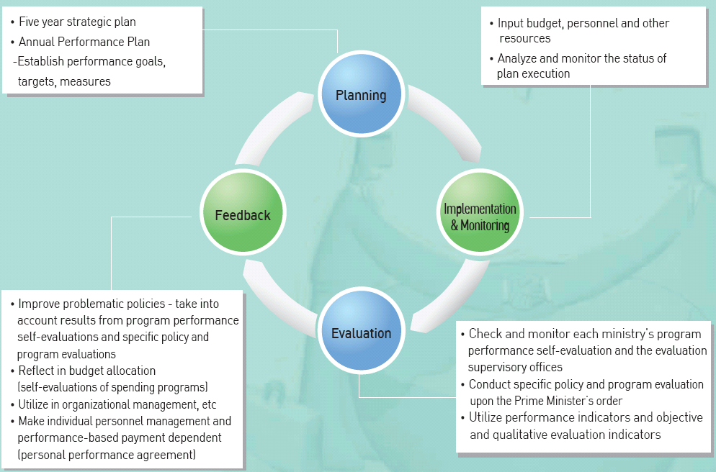

2. Background

The practice of performance management originated from foreign private companies, and since 1990 the public sector has actively taken up the practice in order to enhance the governmental efficiency.
❍ The increase in the level of Korean people’s expectation resulted in increase in government’s expenditure; but the government’s revenue did not match up and the shortage consequently called for efficient government management.
❍ It is more and more emphasized that the government function in a proactive and expeditious manner in solving problems and responding to changes in the socio-economic environment owing to inter-national competition and rapid technological advancement.

In the U.S. a result-oriented performance management system was initiated by GPRA (Government Performance and Results Act, 1993) to ensure government accountability and reinforce the linkage between performance management and budget decisions.

Until mid-1990s, policy management was conducted in such a way that placed more emphasis on inputs and work procedures rather than policy outcomes.
❍ With the increasing demand for national competitiveness and an efficient government, the Korean government began to introduce result-oriented performance management programs for central ministries, including evaluations of government performance, spending programs, and information and technology from the latter part of the 1990s.
 Subsequently, the Korean government adopted the Management by Objective (MBO) program in 2003 for civil servant of Grade 4 or higher at central ministries. The program evolved to personal performance contract which was applied to individual government employees at all levels since October 2004.

Personal performance management: a personnel management system whereby a performance contract is officially entered amongst minister, vice-minister, division and department heads with respect to performance targets and performance indicators. An individual's evaluation results from each year are then taken into account in performance-based payment and personnel matters according to the terms of such agreement.

Performance management of government policies and programs was actively taken on with the legislation of the Government Performance Evaluation Act(GPEA) in 2006. Its objective was to improve and integrate overall performance evaluation programs as well as reduce the burden placed upon evaluatees as resulting from any repetition in the evaluation process.

◈ Administrative Structures for Performance Management

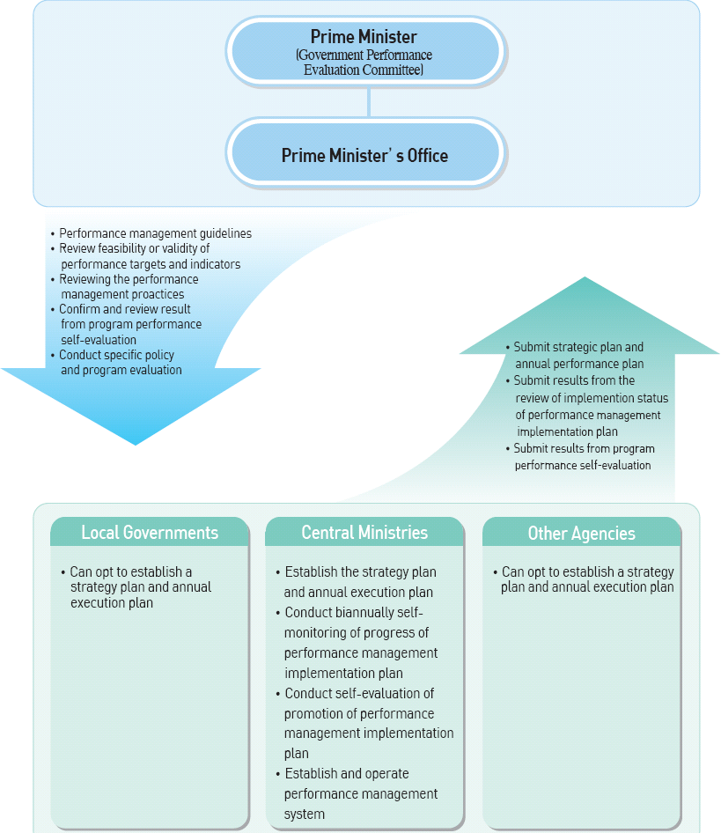
3. History of Performance Management

 | Beginning | Transition |  | Overhaul | Development | Integration
Office in Charge | Prime Minister’s Planning and Coordination Office | Policy and Program Assessment Division of the Ministry of Economy and Planning | Prime Minister’s Administrative Coordination Office | Prime Minister’s Administrative Coordination Office | Policy and Coordination Office, the Deliberation and Evaluation Coordination Office | Prime Minister’s Policy Analysis and Evaluation Office
Time Period | 1961.09 - 1981.10 | 1981.11 ~ 1990.03 | 1990.04 ~ 1994.12 | 1994.12 ~ 1998.02 | 1998.03 ~ 2006.03 | 2006.04 ~ present
Changes | For the first time Assessment system was adopted in 1961 for the evaluation of government policies and programs | The funciton of policy and program assessment was transferred to the Division of the Ministry of Economy and Planning in 1981. | Added a policy evaluation function to the Administrative Coordination Office in the Prime Minister's Office. | A governmental organizational reform resulted in integration of policy and program assessment of the policy planning office and the policy evaluation by the administrative coordination office ; but evaluation of the government's investment agency remained to be under the Economy and Planning Bureau. | With the onset of the People' Government Administration, the assessment system went through a major overhaul resulting in implementation of 'institutional evaluation system.' | The Participation Government Administration initiated an integrated government performance evaluation and performance management system.
Basis | Regulations Concerning the Government's Planning and assessment(Presidential Decree No. 6143, 1972.04) | Regulations Concerning the Government's Planning and assessment (Presidential Decree No. 0821, 1982.05) | Regulations Concerning Evaluation and Coordination of the Government's Major Policies (Prime Minister's Decree No. 364, 1990.04) | Regulations Concerning Evaluation and Coordination of Government Performance (Presidential Decree No. 4531, 1995.02) | The Government Performance Evaluation Act(Law No. 6347, 2001.01.08) | The Government Performance Evaluation Act, an amendment (Law No. 7928, 2006.04.01)

(1) Policy and Program Assessment System(PPAS) of the Prime Minister’s Planning and Coordination Office (1961.9~1981.10)

❍ The PPAS was introduced as a means to promote efficient economic development with limited resources in the historical context of the time. The PPAS called for an evaluation board to conduct evaluation of the implementation process of the Economic Development Plan and execution results. Since the Government's Policy Evaluation Board was formed in 1965 to conduct an interim evaluation of the First Round of the Five-Year Economic Development Project, the evaluation has been undertaken every year. A body of 90 professors conducts evaluation of the government policies and project areas in which each one is specialized.

(2) Policy and Program Assessment System(PPAS) of the Ministry of Economy and Planning (1981.11~1990.3)

❍ The government's organizational reform brought about the transfer of deliberation and analysis task of the Planning and Coordination Bureau to the Ministry of Economy and Planning while keeping the program structure unchanged. For example, the evaluation continued to focus on budget projects. Following results from policy and program assessment, the Minister of the Economy and Planning reflected any issues pertaining to budgets in the budgeting and allocation areas, and the Prime Minister was responsible for requesting corrections for non-budget items.

(3) Policy Evaluation Program of the Prime Minister’s Administrative Coordination Office (1990.4~1994.12)

❍ The policy evaluation program was introduced as an alternative to the criticism that the Ministry of Economy and Planning's policy and program assessment system was limited in diagnosing the trends of national affairs on the holistic level. The new system called for evaluation of one or two specific policies of each ministry based on check lists.

(4) Policy and Program Assessment and Evaluation System of the Prime Minister’s Administrative Coordination Office (1994.12~1998.2)

❍ This system unified the assessment system of the Ministry of Economy and Planning and policy evaluation system of the Administrative Coordination Office. It was divided into a regular assessment and evaluation and on-demand assessment and evaluation. The regular evaluation focused on the evaluation of achievement of policy objectives as was planned and was required to biannually report to the Cabinet Council, and under the on-demand evaluation, the Prime Minister conducted evaluation of matters as necessary with respect to the administration of state affairs.

(5) Government performance evaluation by the Policy and Coordination Office: Institution evaluation (1998.3~2006.3)

❍ The evaluation extended over each institution's policy promotion competency and customer satisfaction in addition to the implementation progress of major polices of each ministry. It was intended to expand upon simple task-oriented evaluation to encourage competition among different institutions. With regards thereto, the Government Performance Evaluation Act was legislated and enforced for the first time in May 2001.

(6) Government performance evaluation by the Policy and Coordination Office (Prime Minister's Office): integrated evaluation (2006.4 ~ Present)

❍ The Government Performance Evaluation committee integrated individual evaluations and developed qualifiable performance indicators with the introduction of a performance management program. The evaluation system was now focused on the self-evaluation whereby each institution conducts self assessment. It stresses that individual performance from the evaluation results be taken into account. The Government Performance Evaluation Act was amended on a full-blown scale and put into enforcement in May 2006.

Ⅱ. Key Aspects of Performance Management

1. Planning

Beginning in 2007 the central ministries have been establishing a five-year strategic plan to set forth each ministry's mission, vision, strategic objectives and five-year performance targets.
Every year ‘annual performance plan’ is established for the Performance Management Strategy Plan in order to present each year’s performance targets and policy (projects) and performance indicators for achieving such objectives.
The Government Performance Evaluation Committee (chaired by both the Prime Minister and a civil-sector person) under the Prime Minister’s Office provides support for planning such as reviewing and coordinating the appropriateness of each central ministry's objective structure and performance indicators.
Strengthen the annual performance plan’s relevancy with national agenda, ministerial plans, and the President’s directives.

Establish annual performance plan guidelines |  | Draft annual performance plan |  | Review and refine annual performance plan |  | Confirm the annual performance plan
(January) |  | (February) |  | (Early March) |  | (Mid March)

Strategic Plan |  | · ・A five-year mid- to long-term plan established by a head of central ministry w which includes its sub-agencies for achieving strategic objectives  · ・It sets forth each institution's mission, vision, strategic objectives and five-year term performance targets, including mid- to long-term finance management plans under the National Finance Act and other mid- to long-term plans under other laws.  · ・Review validity of the plan at least every three years for revision and refinement
Annual performance plan |  | · ・An annual performance implementation plan set forth by the head of a central ministry based on the 'Performance Management Strategic Plan' for achieving performance targets of each year  ・It sets forth each year's performance targets and performance indicators including fnancial performance results of the past three years.

◈ Objectives Structure of the Performance Management Plan
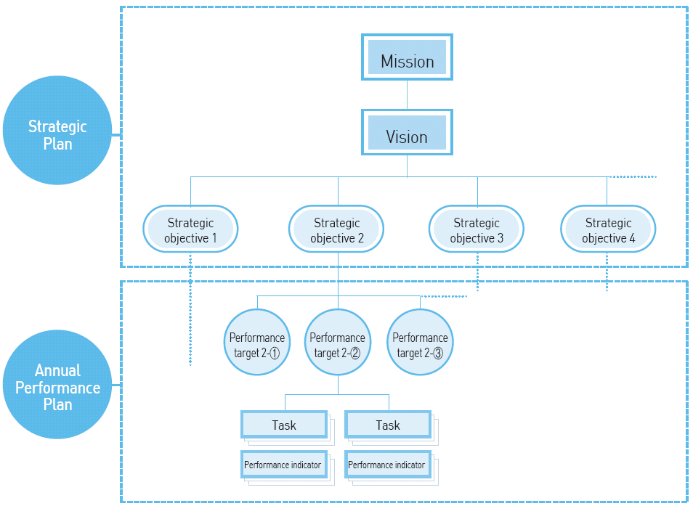

Mission |  | An organization's mission (objective) and major functions
Vision |  | Describes the organization's long-term goals and what it wants to be in the future. Sets forth its policy directions and provides motivation for its members.
Strategic objective |  | The organization's major goals and the directions it should take in light of its mission and vision as well as the objectives of the State.
Performance target |  | Second-level goals that describe strategic objectives in detail; actions to be achieved in a set period.
Task |  | Individual policies or projects being undertaken for achieving performance targets.
Performance indicator |  | Quantitative or qualitative indices for the level of achievement of policies of performance targets and tasks.

2. Implementation and Monitoring

Central ministries shall promote policies by efficient allocation of resources and check on the implementation of task procedures and results so that objectives are achieved properly.
The Prime Minister's Office shall diagnose the standard of government organizations' performance management by reviewing and monitoring the implementation practices of central ministries' performance management and provide support and encouragement for the development of performance management in the government.

3. Evaluation

Central ministries establish evaluation plans in April every year and conduct an annual program performance self-evaluation from January through March on the achievement of the year-end performance results.

※ Performance targets and indicators for each policy and program under the 'Annual Performance Plan' shall be used as targets and indicators for policy and program performance self-evaluation of central ministries.

From November to December of each year, the Prime Minister shall conduct specific policy and program evaluation for those policies and programs for which continuous monitoring is required, that are related to multiple ministries and that are on the current agenda of the government.

A. Features of Government Performance Evaluation

1) Integration of Individual Evaluations

The legislation and enforcement of the Government Performance Evaluation Act (2006.4) has integrated a number of evaluations that used to be conducted separately under previously effective separate laws, and the evaluation aims at performance management for the government work.
The central ministries are now subject to an integrated evaluation system which sets forth subjects and time of evaluation and has improved evaluation method and evaluation indicators. The integrated approach has resulted in raising the efficiency of evaluation while reducing any burden placed upon those evaluatees.

2) Policy and Program Performance Self-Evaluation by Central Ministries

Central ministries conduct policy and program performance self-evaluation according to their own plans and evaluation results are used accordingly. the self-evaluation is intended to reinforce autonomy and accountability of each ministry in performance management.
The head of a central ministry establishes a self-evaluation plan that includes evaluation subjects, method and schedule according to basic guidelines for performance management and government performance evaluation of each year as set forth under the implementation plan for government performance evaluation prescribed by the Prime Minister. The head may also create a self-evaluation committee consisted of 10 to 30 experts from the non-government sector.
The evaluation supervisory offices shall confirm and review major policies, spending programs and administrative management competency of a central ministry's self-evaluation results by each area in order to raise the objectivity and reliability of the self-evaluation.

※ The valuation supervisory offices: Prime Minister's Office, Ministry of Planning and Finance, and Ministry of Public Administration and Security

3) Specific Policy and Program Evaluation (SPPE)by the Prime Minister

❍ An evaluation of central ministries' policies by the Prime Minister for integrated management of national affairs
❍ An evaluation commission shall be created for each area of evaluation consisting of experts from the non-government sector. Evaluation shall be conducted according to the evaluation direction, areas, subjects, indicators, and methods as set forth under the implementation plan for government performance evaluation prescribed by the Prime Minister each year
❍ Results from a specific evaluation shall be confirmed upon deliberation and resolution by the Government Performance Evaluation Committee and be forwarded to each ministry to be taken into account for the next year's planning.

B. Organizations for Government Performance Evaluation

1) Government Performance Evaluation Committee

❍ Co-chaired by the Prime Minister and an expert from the private sector, the GPEC is composed of not more than 15 persons including experts from the private sector and heads of central ministries (Prime Minister's Office, Ministry of Planning and Finance, and Ministry of Public Administration and Security).
❍ The GPEC makes deliberation and resolution on major issues of the government performance evaluation, including matters pertaining to :

- planning, coordination and supervision of government performance evaluation,
- confirming, reviewing, and re-evaluation of each central ministry's self-evaluation,
- planning and implementation of specific evaluation conducted by the Prime Minister, and
- utilization of results from the government performance evaluation and recommendation for liaising different evaluation programs.

2) Self-Evaluation Committee

❍ A self-evaluation committee of central ministry is composed of 10 to 30 persons including one chairperson and two thirds of whom should be from the private sector. The Committee's main function is to conduct self-evaluation of the central ministry and its affiliated organizations on promotion of policies, etc.

C. Overview of Evaluation of Central Ministry for 2010

1) Evaluation Categories

Category |  |  |  | Details
Self-evaluation |  | major policies |  | Evaluate policies that a central ministry wishes to promote with priority within a prescribed time period for achievement of performance targets.
Self-evaluation |  | financial performance |  | Evaluate general spending programs, R&D projects, and information and technology
Self-evaluation |  | administrative management competency |  | Evaluate efforts and performance in the areas of human resources, organization, and information and technology management that are planned to be achieved within a set time period.
Specific evaluation |  | core task |  | Evaluate core functions of the entity and its relevancy with key issues of national affairs
Specific evaluation |  | job creation |  | Evaluate tasks related to major job creation
Specific evaluation |  | green growth |  | Evaluate policies related to national stretegy for green growth and execution of central promotion plan
Specific evaluation |  | policy management competency |  | Evaluate policy issue management, relationship competency such as coordination and integration, and implementation management
Specific evaluation |  | policy PR |  | Evaluate PR planning for major policies, new media PR activities, and policy PR outcome
Specific evaluation |  | regulatory reform |  | Evaluate appropriateness/relevancy of regulations, outcome of regulatory reform, customer satisfaction from regulatory reform
Specific evaluation |  | customer satisfaction |  | Evaluate satisfaction of core policies of each ministry, satisfaction of services provided to Korean people

2) Evaluation Indicators for Core Tasks

Phase |  | Categry |  | Evaluation Indicators
Policy planning |  | - 1. Aappropriateness of  p planning |  | · appropriateness of policies  · · appropriateness of feedback collection and  collaboration with relevant organizations
Policy implementation |  | 2. Thoroughness  in process |  | · compliance with scheduling  · strategic responsiveness
Policy result |  | 3.3. Achievement and implication of  performance |  | · achievement of performance targets  · policy implication

4. Feedback

A. Ministerial Level

1) Policy improvement

If any problem is found in such areas as the evaluation supervisory offices's confirmation, inspection results and policies, the head of central ministry shall make corrections or conduct an audit and submit its results to the Government Performance Evaluation Committee.
   The head of central ministry shall submit to the Government Performance Evaluation Committee on any improvement it has made as recommended from the result of a specific evaluation.

2) Budget implication

If any project is found to fall short in its performance as a result of evaluation, its budget shall be discounted by 10% or more or be abandoned altogether. If a project's performance is not falling short but if its performance is still not demonstrated objectively, no increase is granted.

※ According to the 'self-evaluation of spending program' which has been implemented since 2005, the head of central ministry shall conduct self-evaluation of the performance of a spending program that exceeds a certain range every three years based on the checklist provided for each project. The result shall be rated in the scale of 5 levels of excellent, great, good, poor, and very poor.

3) Organizational management

Evaluation results may be used for organizational management, such as creation or abolition of an organization and personnel placement.
   If an evaluation results in poor grade, an organization shall be subject to a review and be presented with strategies and action plans for organizational management.

B. Feedback for Individual Performance Evaluation

1) Individual performance and personnel management

Evaluation results for a task are reflected in the personnel management of an individual(s) who has undertaken such task.
The introduction of performance management and competition in the government sector aims at enhancing the quality of administrative services and the administrative productivity.
Individual performance is reflected in his or her personnel record. Civil servant of grade 4 or higher shall be subject to personal performance agreement, and those of grade 5 or lower through performance evaluation.
   Results from government performance evaluation shall be taken into account for the performance evaluation of civil servants of grade 4 or higher in each ministry through the personal performance agreement, and it shall be reflected in his or her personnel record.
  Results from government performance evaluation may be reflected in the performance evaluation of those civil servants of grade 5 or lower.

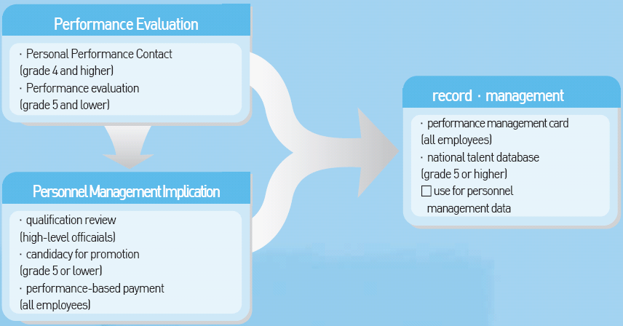

2) Accumulation and utilization of evaluation results

Performance management cards system is implemented beginning in July 2005 with the goal of executing personnel management based on accomplishment and competency. The records include results from government performance evaluation, key accomplishment in the personal performance agreement, supervisor's opinions and final evaluation and can be used for determining candidates for promotion, evaluation of application for vacancy, recommendation for talent, etc.

◈ Performance management card records

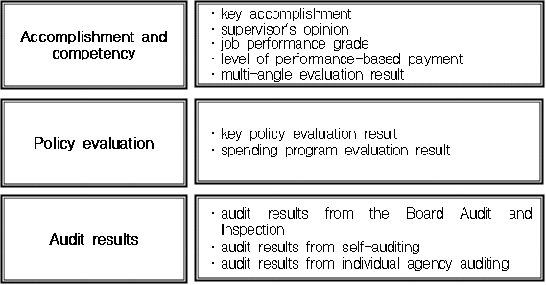

◈ Comprehensive management of performance information

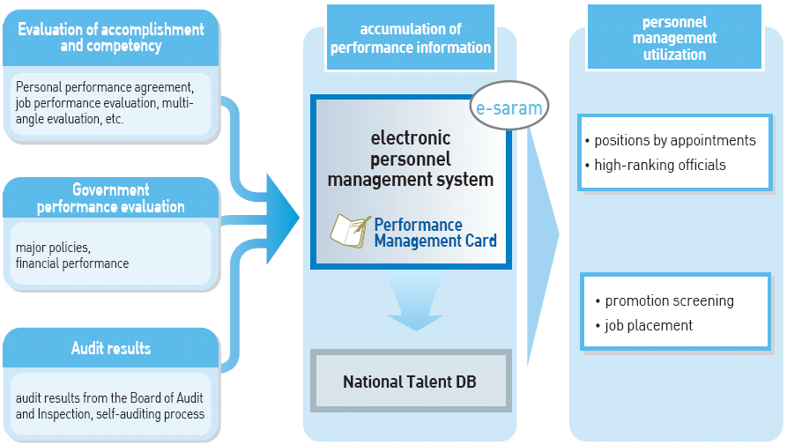

3) Performance-based Payment

Determining performance-based salary

Performance-based salary for high-ranking officials and grade 4 civil servants shall be determined by such factors as results from the evaluation of personal performance agreement that has taken into account results from the government performance evaluation.
   In the event that a high-ranking official has received the lowest grade in the evaluation of personal performance agreement for two years or more, he or she shall be subject to qualification test for the high-ranking position. If the test results in disqualification, he or she may be removed from the position.

◈ Basic model for determining performance-based salary grade for high-ranking officials (2010)

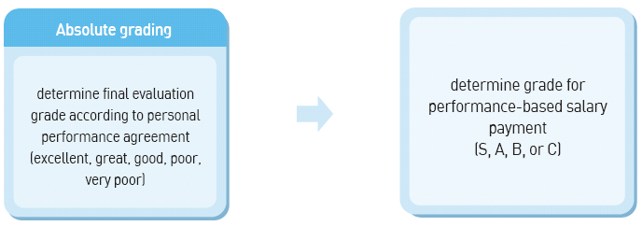

◈ Distribution of performance-based salary grade for high-ranking officials (2010)

Grade | S | A | B | C
percentage of evaluatees | 20% | determined by each ministry |  | 10%
payment rate | 15% | 10% | 6% | 0%

* Payment in 2010: 2009 base pay (80,518,000 won) x payment rate

Performance-based bonus

   Results from the government performance evaluation may be taken into account in determining payment grade for performance-based bonus for those civil servants of grade 4 or lower.

C Continue to increase the portion of performance-based payment in remuneration

· high-ranking officials : 5%(2007) ⇒ 8.5%(2010),
· regular civil servants : 3%(2007) ⇒ 4%(2010)
Ⅲ. Performance Management via e-IPSES

The Korean government has developed the Electronic Integrated Public Service Evaluation System or "e-IPSES" which is designed to allow the management of the entire evaluation process online in order to reduce any burden from taking care of government performance evaluation and performance management work and to raise efficiency.

※ e-IPSES : electronic - Integrated Public Service Evaluation System

When a performance management implementation plan is entered in the e-IPSES, the management task is set as a unit task for the Business Reference Model (BRM) (government's functional classification system) and (subsequently) reflected in the On-Nara Business Process System (BPS), task management system. Once the employee in charge of a task processes documents over the course of a project execution, the work is reflected in the e-IPSES to be used for evaluation.

Evaluation result is sent to a personnel management system for civil servants, 'e-Saram System' and accordingly distributed to individual performance based on the personal performance agreement. Result from a spending program evaluation is linked to the "Digital Budget Accounting System (d-brain)" to be reflected in the budgeting for the following year.

◈ Linkage between e-IPSES and other system

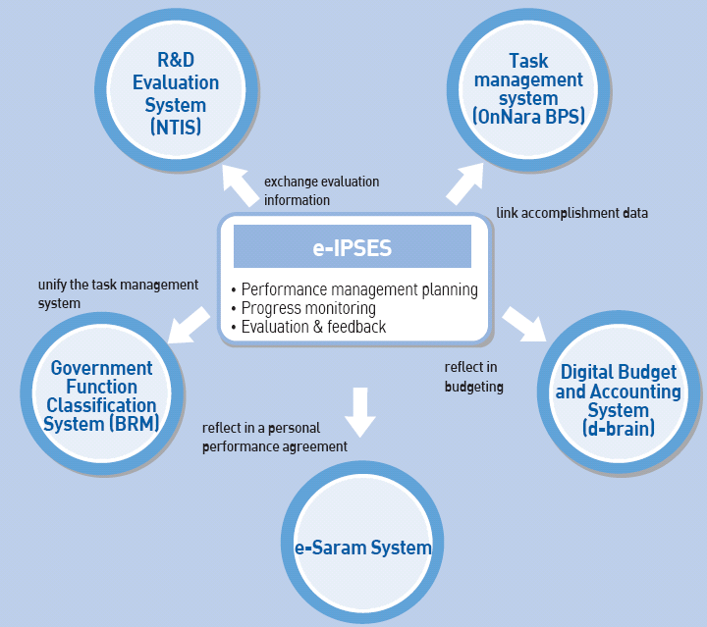

Ⅳ. Best Practice : Korean Intellectual Property Office(KIPO)

1. Overview of KIPO’s Performance Management

The Korea property Office has implemented BSC for performance management since 2005

◈ KIPO's Strategic Framework

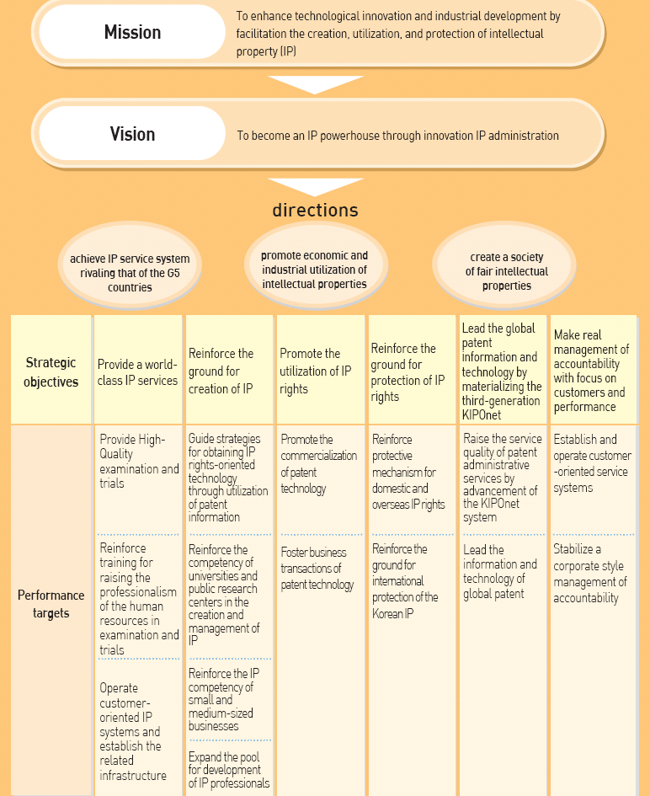

Institutional performance management

Established a strategic plan for 2010 through 2014 in order to become a world's leading nation of the 21st-century IP. The plan is reflected in the annual performance management implementation plan for application to the short- to long-term objectives.
   Communicate to each member of the Office on the potential areas where each individual can make contribution in order to achieve the Office-wide objectives by breaking down the details of the strategies.

Organizational performance management

    Apply a logical model based on the process of input - act - output - result and set KPI in a way policy results and implications can be measured.
    Set a challenging objective by applying the standard deviation of the past three years' results to the previous year's results in order to take into account the development of changes in recent results.
    Frequently monitor performance progress status for each KPI via the BSC performance management system that in order to be able to anticipate performance progress and respond to problems in advance.

Individual performance management

Organic linkage between the organizational performance and individual performance

For a head of a division or department, the KPI for his or her division or department corresponds to his or her individual KPI. The organizational performance result is reflected in the individual performance evaluation.
An individual of grade 5 or lower is evaluated on the contribution he or she has made to the delivery of the organization's performance in his or her individual performance evaluation. The organizational performance evaluation result partly accounts for his or her individual performance evaluation result.

Establishment of a systematic individual performance management process

Any individual of grade 4 or higher is required to enter into a personal performance agreement with his or her supervisor. Those employees of grade 5 or lower set their KPIs upon consultation with their respective department head
Conduct a quarterly feedback consultation for continuous performance management and keep record of the meeting on the online evaluation notes.
Conduct bi-annual performance evaluation following a monitoring of performance progress and performance coaching; provide feedback on performance evaluation through performance consultation.

Utilization of performance evaluation result

Motivate individual performance by utilizing the results in performance-based salary, performance-based payment and promotion screening.
Require those individuals falling in the bottom 1% of the entire pool from the performance evaluation for twice or more in the past three years to participate in competence reinforcement programs in order to enhance job performance capacity.
Set up career development plans and training plans based on the results of performance evaluation.

2. Case study : Individual Performance Management of the Director General of the Intellectual Property Policy Bureau

1) Communication of the mission and vision

   This communication process is the first step in the individual performance management. The Korea Intellectual Property Office has set its mission as to contribute to technological innovation and industrial growth by facilitating creation of intellectual property (IP), rights protection, and utilization and reinforce protection; and vision as to become a world's leading nation in the 21st century's intellectual property.

2) Establish strategic objective, performance target and performance indicators

    The Intellectual Property Policy Bureau has set up three strategic objectives, including reinforcing the basis for the creation of intellectual property and subsequently set forth 19 performance indicators such as "nationwide expansion of the promotion of intellectual property policies."
Each department under the Intellectual Property Policy Bureau added common performance indicators to the allocated performance indicators, setting up a total of 8 to 10 performance indicators.

Strategic objective | performance indicator | area
Reinforce the basis for IP creation | nationwide expansion of IP policies | major policies
Reinforce the basis for IP creation | degree of the promotion of reinforcing IP competency for small and medium-sized businesses | major policies/financial performance
Reinforce the basis for IP creation | six other indicators | major policies/financial performance
Promote utilization of IP rights | productivity of patent technology transactions | major policies/financial performance
Promote utilization of IP rights | rate of the utilization of support projects for commercialization of excellent patent technology | major policies/financial performance
Promote utilization of IP rights | three other indicators | major policies/financial performance
Reinforce protection mechanism for IP rights | index of elimination of distribution of forged products | major policies/financial performance
Reinforce protection mechanism for IP rights | fullness of the improvement of mechanism for the protection of trade secret | major policies
Reinforce protection mechanism for IP rights | four other indicators | major policies/financial performance

3) Personal performance agreement

    The Director General of the Intellectual Property Policy Bureau set up the BSC performance management plan for his bureau with emphasis on the performance targets and indicators relevant to his responsibilities as selected from the KIPO's performance targets and indicators, and entered into a personal performance agreement with his superior.
    Following the signing of the personal performance agreement, he has been provided with a quarterly monitoring of his progress on the performance indicators. An interim evaluation is conducted as of the end of June and an yearly evaluation as of the end of December.

4) Performance evaluation

Results evaluation

Since the performance indicators for the Intellectual Property Policy Bureau corresponds to the Director General's personal performance agreement for the most part, the organizational performance evaluation accounts for his individual performance evaluation.
The director general is evaluated against his performance indicators by the KIPO's organizational evaluation taskforce on such areas as the thoroughness of planning, thoroughness of execution process, and degree of goal achievement.
    The performance targets and performance indicators of the performance management implementation plan are subject to the government performance evaluation, and the Government Performance Evaluation Committee may adjust the evaluation grade upon its verification and review.

◈ Performance evaluation result for the Industrial Property Policy Bureau
performance indicators | weight | score | converted score
nationwide expansion of IP policies | 8% | 95 | 7.6
degree of the promotion of reinforcing IP competency of small and medium-sized businesses | 5% | 90 | 4.5
productivity of patent technology transactions | 5% | 94 | 4.7
16 other indicators | 87% | - | 79.5
total | 100% | - | 96.3

Competency evaluation

    The director general's immediate superior (Deputy Commissioner) and the next superior (Commissioner) evaluate him on the general competency (2 categories) and leadership competency (8 categories) according to the KIPO's own competency model which is based on the competency model for high-ranking officials.

◈ Competency evaluation result for the Intellectual Property Policy Bureau
competency | category | weight | 1st evaluation | 2nd evaluation | total
general competency | customer satisfaction | 10% | 10 | 9 | 9.5
general competency | challenge and creativity | 10% | 10 | 10 | 10
leadership competency | training of subordinates | 10% | 8 | 8 | 8
leadership competency | creation of an organizational culture | 10% | 10 | 9 | 9.5
leadership competency | vision sharing | 10% | 9 | 10 | 9.5
leadership competency | initiating changes | 10% | 10 | 9 | 9.5
leadership competency | strategic thinking | 10% | 8 | 9 | 8.5
leadership competency | decision making | 10% | 9 | 10 | 9.5
leadership competency | quality improvement | 10% | 9 | 9 | 9
leadership competency | performance management | 10% | 10 | 9 | 9.5
total |  | 100% | 93 | 92 | 92.5

Attitude evaluation

Score based on the KIPO's personnel management regulations.

KIPO Mileage

Grant certain bonus points for activities that have contributed to the development of the KIPO's administration, such as creative thinking and efficient job execution.
The director general gained 0.2 KIPO mileage point for his ideas for policy improvement.

Total evaluation scores

 | Performance |  |  | competency | attitude | bonus points |  | totla score
 | bureau evaluation | department evaluation | individual performance | competency | attitude | KIPO  mileage | special points | totla score
points | 70 | - | - | 25 | 5 | +a | +ß | 100+
score | 67.41 | - | - | 23.13 | 5 | 0.2 | 0 | 95.74

5) Utilization of performance evaluation result

   The performance evaluation results are reflected in the personnel management matters such as performance-based salary, job placement, and training opportunities.
  His key performance accomplishment and evaluation feedbacks for each category of his personal performance agreement are recorded on the e-Saram performance management card for storage on the National Talent Database.

3. Impications

1) Raise job focus through general performance targets

    Involve most members of the organization in setting forth its mission and vision as well as performance targets and indicators of each department.
Since the BSC-based performance management system in 2005, the overall satisfaction of KIPO's customers has increased from 68.2 points in 2005 to 73.8 points in 2010 with the implementation of Claim-by-Claim examination, Three-track patent examination and other customer-oriented administrative programs of KIPO.

2) Thorough management of tasks - progress monitoring for each performance indicator

    Regular monitoring of job execution progress with the BSC-based performance management system allows anticipation of job performance and prior response to problems.
   The reinforcement of quality-oriented examination system resulted in the decrease of the KIPO's rate of errors in examination from 2.3% in 2005 to 1.2% in 2010. It includes implementation of examination quality index with the organizational performance indicators of the examination department.

3) Open and transparent evaluation culture

Ensure reliability of the evaluation with the objectivity in evaluation as based on the criteria and indicators that are presented in advance and raise predictability of individual performance management.

